Report No.

Serbia:

Municipal Finance and Expenditure Review
January 31, 2013

Poverty Reduction and Economic Management Unit
South East Europe Country Unit
Europe and Central Asia Region



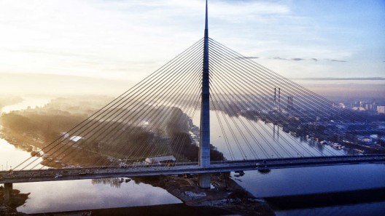

Document of the World Bank

CURRENCY EQUIVALENTS

Currency Unit – 85 RSD= 1 US$

WEIGHTS AND MEASURES

The Metric System is used throughout the report.

FISCAL YEAR

January 1 to December 31

ABBREVIATIONS AND ACRONYMS
EU | European Union
GSP-Beograd | Belgrade public transit company
HBS | Household Budget Survey
IBNET | International Benchmarking Network for Water and Sanitation
MOF | Ministry of Finance and Economy
MRDLG | Ministry of Regional Development and Local Government
PEDPL | First Programmatic Public Enterprise Restructuring Development Policy Loan
PUC | Public Utility Company
PUPA | Business Association of Private Transport Operators

Vice President: | Philippe H. Le Houerou
Country Director: | Ellen Goldstein
Sector Director: | Yvonne Tsikata
Sector Manager: | Satu Kahkonen
Task Team Leaders: | William Dillinger and Lazar Sestovic

FOREWORD

This report is based on the findings of a series of missions to Serbia in 2012. The report was prepared by William Dillinger, with the assistance of Lazar Sestovic. The chapter on transport was prepared by Carolina Monsalve and the chapter on district heating by Bernd Kalkum (consultant). The report has benefitted from the assistance of a wide range of Serbian counterparts. These include staff of the Ministry of Finance and Economy, the Ministry of Regional Development and Local Government, the Fiscal Council and the Standing Committee of Towns and Municipalities. The authors wish to particularly acknowledge the assistance provided by the municipalities of Belgrade, Kragujevac, Aleksinac, Nis, Subotica, Arandjelovac, and Kanjiza.

This report was prompted by a concern, voiced by the Ministry of Finance and Economy, the Fiscal Council and some members of the donor community, that local governments in Serbia have too much money. While the Serbian central government is facing tight budget constraints, it is argued that local government are over-funded—a view reinforced by the recent increase in the local governments’ share of the personal income tax. This report is aimed at investigating this charge. In the process, it closely examines the nature of local government spending—the functions that local government provide—with an eye to identifying how these services might be provided more cost effectively or at less cost to the central government.

A follow-on report, financed by the Swiss government, will examine certain aspects of local government and municipal utility management in greater detail, including staffing and compensation policies, financial management, and capital investment planning.

cover photo: new Ada Bridge over the Sava River, a project of the City of Belgrade.

Serbia: Municipal Finance and Expenditure Review

Executive Summary 4
Introduction 11
System of Local Governments in Serbia 12
Functional Responsibilities 12
Revenues 14
Trends in Local Fiscal Performance 21
Macro Context 21
Local Government Fiscal Performance 23
Impact of the Decentralization Law 25
Do Local Governments Have Too Much Money? 27
Directions for Reform 31
Reducing Central Fiscal Support 32
Decentralizing Expenditures 32
Raising Local Revenues 33
Property Tax 34
Other Revenue Opportunities 36
Cutting Subsidies to Municipal Enterprises 37
Water Supply 38
District heating 41
Public transit 47
Other municipal enterprises 52
Fundamental management reforms 53
Controlling Municipal Borrowing 54
Contractual Debt 54
Municipal Arrears 57
Summing Up 59
Annex 1 Case Studies 61
Belgrade 61
Kragujevac 65
Nis 67
Subotica 69

Executive Summary

This report was prompted by a concern, voiced by the Ministry of Finance and Economy, the Fiscal Council and some members of the donor community, that local governments in Serbia have too much money. While the Serbian central government is facing tight budget constraints, it is argued that local government are over-funded—a view reinforced by the recent increase in the local governments’ share of the personal income tax. This report is aimed at investigating this charge, as well as identifying potential savings at the municipal level given Serbia’s urgent need for fiscal consolidation. In the process, it examines the nature of local government spending—the functions that local government provide—with an eye to identifying how these services might be provided more cost effectively.

Background Although authorized to perform a wide array of functions, the primary responsibilities of Serbia’s 165 local governments are largely confined to infrastructure services. These include urban water supply and sewerage, local road maintenance, solid waste management and, in more urban municipalities, district heating, and public transport. These functions are typically performed by municipally owned public enterprises, which cover part of their operating costs through tariffs. Local governments also perform a more limited set of social services. These include the operation of preschools and the maintenance of school buildings (although not the payment of teachers salaries).

As a group, local governments derive the majority of their revenues from four sources: a share of the centrally administered personal income tax (PIT), a formula-based recurrent transfer from the central government, local taxes, and local fees. The importance of each of these sources, as well as the level of revenues they generate, varies widely among jurisdictions. While the PIT is the largest single municipal revenue source in virtually all municipalities, it generates far more revenue per capita in Belgrade than in smaller jurisdictions. Similar, the yields of local taxes, per capita, are far higher in Belgrade than in smaller jurisdictions. Transfers, on the other hand, are a more important source of revenue in smaller jurisdictions. One other characteristic distinguishes municipalities from each other. Prosperous and growing municipalities derive a significant amount of revenue from land development fees—charges imposed as a condition of construction permit approval. Municipalities in economic decline do not.

Recent fiscal performance

The macro context For Serbia, the last five years have been a time of economic and fiscal turbulence. During the prior period (2001-2008) the economy grew rapidly. However, as the global economic crisis escalated, Serbia’s economy faltered. In 2009, the economy entered a recession, with GDP falling 3.5 percent. The authorities responded with a fiscal adjustment package, supported by the IMF. Spending was reduced through a nominal wage and pension freeze and cuts in subsidies and capital expenditures. But revenues fell sharply, reflecting a contraction in aggregate demand. As a result, the 2009 fiscal deficit increased to 4.5 percent of GDP. The subsequent economic recovery was modest, with GDP growing by just one percent in 2010 and 1.6 percent in 2011. Since then, the economy has faltered again. The year 2012 was particularly difficult for Serbia, marked by hotly contested elections, severe weather conditions, the closure of the major steel exporter and the failure of two state banks. It is estimated that the economy shrank by two percent in 2012. The fiscal balance has also worsened. From 2009-2011, the consolidated government deficit ranged between 4.5 percent and 4.9 percent of GDP. In 2012, the newly formed government responded by adopting a supplementary budget, with corrective measures on both the revenue and expenditure side. The VAT rate was increased from 18 to 20 percent. The indexation formula for pensions and public sector salaries was temporarily set aside and expenditures. These measures were insufficient to reduce the deficit. The consolidated general government deficit reached 5.3 percent of GDP in the first eleven months of the year. The estimate for the full year is 6.2 percent of GDP. Adding costs associated with the recapitalization of the failed banks and the clearance of arrears brings the headline deficit to 7.7 percent of GDP. Based on these and other measures, the 2013 budget targets a deficit of 3.6 percent of GDP. The feasibility of this target remains in dispute, however.

Under these circumstances, it is imperative that the Government find ways to further reduce expenditures. As part of this process, it must find ways to reduce the level of financial support it provides to local governments

Local Fiscal Performance The aggregate financial performance of Serbian municipalities has fluctuated widely in recent years, largely in tandem with economic and fiscal developments at the national level. Current revenues grew 30 percent in real terms between 2005 and 2008. Expenditures increased at roughly the same rate, resulting in a small aggregate deficit in 2007 and a small surplus in 2008. With the onset of the fiscal crisis, revenues dropped by 20 percent in real terms. This was partly due to a real decline in PIT and other tax revenues. But it also reflected a Government decision to deliberately underfund the transfer system. Municipal expenditures also fell, but not as rapidly. As a result, municipalities, as a group, ran a deficit equal to nine percent of revenues in 2009. Most of this was financed through borrowing. Again, the pattern of adjustment varied among jurisdictions. Belgrade alone accounted for most of the aggregate municipal deficit—and most of the municipal borrowing--in 2009. Other jurisdictions adjusted more dexterously.

In mid-2011, despite the ongoing fiscal crisis, the Government doubled the municipal share of the PIT—from 40 percent to 80 percent. It made no corresponding transfer of expenditure responsibilities. It also made adjustments to the transfer system, committing to fully funding the transfers but imposing ceilings on the amounts to be transferred to the more developed jurisdictions. These last two changes are expected to cancel each other out: the reductions for developed municipalities will offset the commitment to fully funding the transfer as a whole. But overall, the net impact of these reform will be an increase in municipal revenues equal to about 1.3 percent of GDP (compared to 2010 levels) and a corresponding loss in central government resources.

Reducing central fiscal support The Government is now looking for ways to restore the former fiscal balance. Several strategies present themselves. By far the most straightforward way to restore the former fiscal balance would be to reduce this central fiscal support. And the most straightforward way to do this would be to reduce the share of the PIT that is retained by the municipalities. The former level of tax sharing may have been too low. At the time the system was set in place, there was no a priori reason for settling on 40 percent. But neither is there a priori justification for 80 percent. The share could be reduced to an intermediate level, say 60 percent. An alternative (or complement) to this reform would be to reduce the level of transfers. At present, the total amount to be transferred is fixed at 1.7 percent of GDP. This percentage could be reduced.

Decentralizing expenditure responsibilities Rather than doing either of these things, the Government is instead pursuing remedies on the expenditure side; attempting to offset the increase in municipal revenues through a corresponding transfer of expenditure responsibilities. Roads are the initial target. Five thousand km of regional roads, previously a responsibility of the central government road enterprise, are to be transferred to the municipalities. But municipalities have been reluctant to assume responsibility for them. To encourage them, the 2013 budget allocates RSD 4 billion (0.12 percent of GDP) to finance the costs of maintaining the decentralized roads. This is equal to approximately forty percent of the amount the Government had been spending on maintaining those roads. While this may succeed, it will reduce any savings to the central government budget, at least in 2013. Another idea is to require municipalities to pay a share of the salaries of the teachers in their jurisdictions. This idea is also ill-advised, although its specific drawbacks will depend on how it is implemented.

Increasing local revenues Another tack would be to increase the yield of local revenues. This would not directly reduce the fiscal burden that municipalities impose on the central government. But it might provide a justification for doing so: increasing local revenues would partly offset the need for tax sharing and transfers.

In principle, the urban property tax, along with its companion fee for use of urban land, would appear to be promising candidates. At present, property owned by legal entities (as opposed to physical persons) is grossly undervalued. Tax rates (on property owned by legal entities and by physical persons) are extremely low. Substantial revenues could be raised by addressing these problems. There are reasons to view the this option cautiously, however. The property tax--and particularly the property tax on owner-occupied housing—tends to be extremely sensitive in political terms. As a result, few European countries (with the conspicuous exceptions of the UK and France) generate significant revenue from it.

Municipalities could also generate revenue by better exploiting their role in land development. One route would be to increase the level of land development fees in outlying areas. Some municipalities could also generate considerable income through the sale or lease of land they own outright

Reducing subsidies to enterprises Another option is to reduce local expenditures. (Again, this would not directly reduce the fiscal burden that municipalities impose on the central government but could provide a justification for doing so.) One promising target is subsidies to municipal enterprises—particularly in the water supply, district heating, and public transport sectors. Except in public transport, the scale of explicit subsidies to municipal enterprises in these sectors is relatively small. This is because the capital costs of providing these services are paid directly from the municipal budget. But the financial burden imposed by these capital costs is large, and is likely to increase as Serbia seeks to comply with EU pollution standards.

In principle, the most direct way to reduce subsidies (both explicit and implicit) would be to increase tariffs on services provided by municipal enterprises. Tariff discounts and exemptions are particularly rife in the public transport sector. In Belgrade, anyone under high school age or over the age of 65 rides for free, along with members of the armed service and pregnant women. Although some degree of subsidy can be justified on affordability grounds, the present system of broad-based exemptions is too extravagant.

But raising tariffs alone merely allows the enterprises to pass along the inefficiencies of their operations onto consumers. The evidence suggests there is plenty of room to reduce costs at the same time. In the water and district heating sectors, this could be accomplished by improving leak detection (to reduce technical losses) and metering individual household consumption (to reduce the volume of water and heat that the companies must produce and distribute). In the district heating sector, there is also a case for rationalizing networks, cutting off low density areas where district heating is not cost effective. In the transport sector, similarly, savings could be achieved by reducing the frequency of service on underused lines.

The transport sector offers other opportunities. Tariff enforcement in the Belgrade transit system has been notoriously poor. Until recently, passengers were allowed to enter buses without presenting tickets or passes. Although they were subject to random checks by roving inspectors, these were routinely evaded. In early 2012, the city introduced a new electronic ticketing system. In principle, passengers were required to validate electronic tickets on a scanner posted at the entrance to each vehicle. For a time, evasion appears to have dropped. But in September, the mayor announced that passengers with monthly prepaid subscriptions no longer have to validate their tickets.

The mayor should reverse this decision. But more fundamental reforms will also be useful. At present, city-owned companies have a monopoly on streetcar-, trolley-, and certain bus lines. Much of the remaining bus service, however, is provided by private companies under contract to the city. There are two problems with the current contracting system. First, companies are reimbursed on the basis of gross costs, rather than costs-net-of-tariff-revenue. As a result, they have no incentive to enforce tariff collection. Second, contracts are awarded without competition. Thus companies have no incentive to improve efficiency in order to under-price their competitors. The contracts will come up for renewal in 2015. At that time, the city should award contracts on the basis of net, rather than gross, costs. And it should consider opening some lines to competition.

Are more fundamental reforms needed? The Government’s draft Strategy for Restructuring Public Utilities claims that it is poor management that ultimately accounts for the poor performance of municipal enterprises. It attributes these weaknesses, in part, to the politicization of management—the tendency of managers to be appointed for political reasons (rather than competence) and to change with every change in local political leadership. As a result, it is claimed, even competent managers focus on short term results. To address this problem, the draft strategy proposes that at least half the members of managing boards be people with relevant professional experience. Their terms should be staggered so as to ensure continuity over electoral cycles. By the same token, the managing directors of public utility companies should be required to have at least five years relevant work experience. The draft strategy proposes that both board members and managers be required to disassociate themselves from political affiliations. These are all commendable proposals.

Controlling municipal borrowing: In addition to the burden that local governments currently impose on the central government budget, another claim on the Government is looming on the horizon in the form of a future explosion of municipal debt—and demands for bailouts. In aggregate, the level of municipal debt in Serbia is not high. The stock of local government debt as of end-October 2012 was equal to only two percent of GDP. But there are several causes for concern. The first is the particular case of Belgrade. Belgrade’s stock of debt is large and growing. As of end-2011, the stock of debt owed directly by the city was equivalent to nearly 60 percent of the city’s current revenue. A second reason is that other large municipalities may be following Belgrade’s example. (Several municipalities, for example, have recently floated bonds and many more plan to do so.) A third concerns the terms on which the debt is contracted. The vast majority of municipal debt is on variable interest rates and denominated in foreign currencies. Thus municipalities are acutely vulnerable to rising interest rates or falling rates of exchange.

What is to be done? One obvious first step would be to tighten regulations on municipal borrowing. In some respects, current central government regulations on local borrowing are already fairly restrictive. For long term (>1 year) debt, ceilings are imposed on both the stock of debt and the level of debt service. But the ceilings are waived entirely for loans with maturities of five year or more, if certain short term fiscal requirements are met. This loophole should be closed.

Ex ante regulations on local government borrowing do not, of course, prevent ex post defaults. To forestall defaults, the government must maintain a credible no-bailout policy. Current law provides that, if a municipality fails to honor its debt service obligations to a creditor, the central government may pay those obligations on the municipality’s behalf and deduct the amount from the shared taxes and intergovernmental transfers. This is a useful provision. But the Government should use this device only in extremis and—when it does—deduct the required debt service without exceptions.

By the same token the government should not create bailout expectations with respect to the growing stock of municipal arrears. In January 2013, the MOF announced a plan to refinance local government arrears to construction firms. Debt service is to be deducted from shared taxes and transfers over the following three years. It is conceivable that only legitimate claims for payment will be presented by the construction companies and that the Government will manage repay itself by deducting debt service at source. But it is also conceivable that unscrupulous contractors will present illegitimate claims (in the hope of obtaining legitimate government refinancing). Worse yet, it is conceivable that the Government will find itself politically unable to withhold the required debt service from the municipalities. Under such conditions, the Government will be under pressure to again refinance the arrears, setting a dangerous precedent for the future. Therefore, the program should be curtailed.

Summing up This report is focused on the Government’s immediate concern: the fiscal deficit and the contribution that recent increases in municipal resources have made to it. It is clear that during the current fiscal crisis, reductions in central government spending must be accompanied by reductions in local government spending. The only immediate question is how.

The best approach would be the direct approach: the Government should roll back the recent increase in the municipal share of the PIT. An alternative would be to reduce the level of block transfers. Adjusting on the expenditure side—transferring new expenditure responsibilities from the central government to local governments—is not a promising solution.

At the same time, municipalities could take actions that would reduce their need for central fiscal support. One way would be to remove constraints on the yield of locally-administered taxes and fees. Another approach would be to reduce the fiscal burden posed by public utilities, by increasing tariffs and improving efficiency. None of these measures would, of course, directly reduce the fiscal burden that municipalities now impose on the central government. But they would permit the central government to scale back its fiscal support to municipalities without necessarily forcing a decline in the quality of municipal services.

Instead, there is now a risk that municipal claims on the central government could grow, in the form of demands for debt bailouts. To forestall this outcome, the Government should close the gap in the debt ceiling, refrain from refinancing arrears, and aggressively recover debt service from municipalities in default on their existing obligations.

While the deficit is the immediate focus of this report, broader problems in intergovernmental relations also need to be addressed. The fiscal relationship between the central government and the municipalities is becoming increasingly dysfunctional. Since the current structure was put in place in 2007, the Government has arbitrarily reduced the level of transfers and then increased the municipal share of the PIT, and opened a gaping hole in the debt ceiling. It is now planning to refinance municipal arrears, setting a dangerous precedent. There is a strong case for returning to a stable and transparent system of intergovernmental finance, backed by hard budget constraint. It need not necessarily match the 2007 system. But it should provide local governments with a clear indication of the level of resources they can expect in future years and then force them to make do within that envelope. There is also considerable room for improvement in the internal management of municipalities. These issues will be addressed in the next phase of this work.

SUMMARY OF RECOMMENDATIONS

ADDRESSING THE CURRENT FISCAL DEFICIT
Direct measures
Roll back the increase in the municipal share of the PIT
Reduce the level of block transfers
Indirect measures
Reduce the need for fiscal support to LGs
Remove constraints on yields of locally administered taxes and fees
- value industrial/commercial property at market prices
- raise land development fees to cost-recovery levels
Reduce the need for municipal subsidies to enterprises
- increase tariffs and cut exemptions on public transit
- improve tariff collection enforcement on public transit
- ration service demand by metering individual water and district consumers
- rationalize public transit and utility networks
FORESTALLING FUTURE CLAIMS ON THE CENTRAL BUDGET
- restore former ceiling on long term debt
- end central government refinancing of municipal arrears
- vigorously enforce debt service collection on existing arrears
FUNDAMENTAL STRUCTURAL REFORMS: STABILIZING THE SYSTEM
- after municipal share of PIT is reduced to sustainable level, retain at that level over the medium term;
- after the level of block transfers is reduced to sustainable level (as share of GDP), retain at that level over the medium term, simplify distribution formula, and ensure that transfers are fully funded in annual budget.

Introduction

- Local governments account for about fifteen percent of total public expenditure in Serbia. They are responsible for a wide range of functions, including both infrastructure and—to a smaller extent--social services. On the infrastructure side, their functions include water supply, sewerage, district heating, and public transport. Municipalities are also responsible for urban street and rural road construction and maintenance. In the social sectors, municipalities are exclusively responsible for preschool education. They are also responsible for the operation and maintenance of primary and secondary school buildings, and certain cultural facilities and social services.

- There are both macro and micro reasons for examining the expenditures of municipal governments in Serbia. On the macro side, municipalities are accused of unjustifiably contributing to the aggregate fiscal deficit. Serbia is now in the midst of a fiscal crisis. From 2009-2011, the consolidated government deficit ranged between 4.5 percent and 4.9 percent of GDP. In 2012, in grew to 7.7 percent of GDP. This is in part due to pre-election spending by the previous government and lower revenue yields. But it also reflects a decision by the previous administration to double the share of personal income tax revenues transferred to local governments, without any corresponding transfer of expenditure responsibilities. Under current revenue sharing arrangements, the central government transfers the vast majority of personal income tax revenues to the municipalities and also funds a complex system of block transfers. At the same time, it continues to directly finance the costs of high-ticket items, such as teachers’ salaries and health care. Some degree of subnational financial dependence should be expected in Serbia. Throughout the world, local governments derive the majority of their revenues from central government transfers. But in Serbia, it can be argued that municipalities take too large a share of the public sector pie and have too little to show for it. The previous government’s decision to suddenly increase the municipal share of the personal income tax in the midst of a fiscal crisis was particularly untimely.

- On the micro side, concerns have been raised about the efficiency of municipal spending. Critics have accused local governments of overstaffing and excessive subsidies to enterprises that could, in principle, be financed through tariffs. They also note the high proportion of expenditures devoted to administration. To an extent, the macro and the micro issues are linked. If municipalities were run more efficiently and subsidies to municipal enterprises were reduced, the central government could reduce the level of financial support it provides to the local level.

- The central aim of this report is to investigate these claims and, on the basis of its findings, propose appropriate reforms. These include reforms that could be undertaken by individual local governments and reforms in the overall framework in which municipal governments operate. Such recommendations are timely. With persistent macroeconomic imbalances and a significant fiscal gap, the central government is eager to examine options for change.

System of Local Governments in Serbia

- The Constitution of Republic of Serbia (2006) and the Law on Local Governments (2007) provide for a single tier of local administration, the municipalities. There are 165 of them. Belgrade, as the capital and the largest city, has a special status with its own legislation. Twenty other large urbanized municipalities—including Novi Sad, Nis, and Kragujevac--have a special status under the local government finance system (see below). All municipalities have elected assemblies (ranging from 19 to 75 members) whose members serve four year terms. The municipal executive (the president of municipality) is elected by the local assembly and serves a four-year term.

- In population terms, Serbia’s municipalities are relatively large by European standards. According to estimates by the Serbian Statistics Office, the vast majority of Serbian municipalities have populations in the 10,000-100,000 range (Table 1). Only ten municipalities have populations under 10,000 and two of these have populations in the 9,000-9,999 range. The average municipal population (including the municipalities comprising Belgrade and Nis) is roughly 44,000, which is considerably larger than in most continental European countries. As geographical subdivisions of the national territory, municipalities encompass both urban and rural areas. (Roughly 70 percent of the territory of the City of Belgrade, for example, is classified as rural.) Under the local government law, municipalities have the authority to create subordinate units of administration (mesna zajednica, in Serbian parlance) to serve parts of the municipality, including rural villages, but these are not independent legal entities.
Table 1: Population Size of Serbian Municipalities, 2010 mid-year estimates

Size Range | N. | Pct of Muns. | Population | Pct of Pop.
100,000+ | 18 | 10.9 | 3,025,671 | 41.5
10,10,000-99,999 | 137 | 83.0 | 4,196,556 | 57.6
< 10,000 | 10 | 6.1 | 69,209 | 0.9
Total | 165 | 100.0 | 7,291,436 | 100.0

Functional Responsibilities

- Although authorized to perform a wide array of functions, the primary responsibilities of local governments are confined to infrastructure services and a limited set of social services. As noted above, the key urban infrastructure responsibilities of municipalities include urban water supply and sewerage, local road maintenance, solid waste management and, in more urban municipalities, district heating, and public transport. These functions are typically performed by municipally owned public enterprises. Municipalities also control a vast number of other enterprises, engaged in such activities as the solid waste management and the maintenance of parks. To varying degrees, these enterprises are financed from tariffs, which the enterprises retain. Budget data on municipal spending in these sectors therefore includes only subsidies financed from the municipal budget and expenditures made by municipalities on the enterprises’ behalf. This includes most capital expenditure. In Serbia, it is normally the municipality, not the enterprise, that pays for the capital cost of extending water, sewer, and district heating lines into new areas of development, as well as major investments in trunk lines, pumping facilities, and heating plants.
- The functional distribution of municipal budgetary expenditure is itself somewhat difficult to determine, particularly in the infrastructure sectors. Table 2 shows the average level of per capita spending, by function, for three groups of municipalities: Belgrade, the other three largest cities, and a sample of ten smaller jurisdictions. As shown in the table, the category ‘community development’ is the largest single category of expenditure in all three groups, accounting for about twenty percent of Belgrade’s expenditures and an equal percent in the other jurisdictions. This category includes budgetary expenditures on water supply, sewerage and district heating. But as described in Annex 1, it also includes anomalous expenditures. In the case of Belgrade, for example, it includes the expenditures on the construction of the massive new Ada bridge, as well as the construction of housing for government employees. In Kragujevac, it includes spending on urban redevelopment projects, including the construction of housing for displaced residents. Municipalities are also responsible for the construction and maintenance of urban streets and rural roads. As shown in Table 2, these expenditures consume 24 percent of Belgrade’s expenditures, but only 12 percent of the spending of the other three cities, and virtually none at all of the smaller municipalities’.
Table 2 Sectoral Distribution of Municipal Expenditure by Function
(RSD per capita, 2010)
 | Belgrade | Other 3 Cities | Sample of 10 Smaller Jurisdic-tions
Community Development | 13,311 | 5,024 | 5,827
Economic Affairs | 14,372 | 4,645 | 1,718
road transport | 11,143 | 3,525 | 7
Education | 7,692 | 4,446 | 4,026
preschool education | 5,390 | 2,559 | 1,665
elementary education | 1,662 | 1,105 | 1,318
Social Protection | 3,266 | 1,337 | 1,351
General Public Services | 4,117 | 4,318 | 4,466
general services | 2,233 | 3,482 | 2,717
debt service | 1,548 | 55 | 309
Culture | 2,593 | 2,081 | 2,554
Police and Fire Protection | 45 | 159 | 18
Environment | 313 | 1,214 | 629
Health | 321 | 180 | 115
Total | 46,029 | 28,489 | 20,704
Note: excludes expenditures of municipal enterprises financed from tariffs and other own-source revenues.

- The proportion of municipal spending devoted to the social sectors is relatively modest in Belgrade, but is quite significant in smaller jurisdictions. Judging from the available data, municipalities devote about 15-20 percent of their budgets to education. The majority is devoted to preschool. Municipalities must finance 100 percent of the costs of optional preschool education for children up to age six, although part of these costs can be recovered through fees. In Belgrade, for example, expenditures on preschool totaled RSD 8.056 billion in 2011, or about ten percent of total expenditures. Of this, RSD 3.128 billion was financed from fees paid by parents. In the sample of other jurisdictions, spending on preschool education accounted for just under ten percent of total spending. Spending on primary and secondary education is considerably smaller. As noted earlier, the central government directly pays the salaries of teachers and other education personnel. Municipal spending on primary and secondary education therefore represents only the costs of heating, lighting, and other utilities, as well as routine maintenance. In Belgrade and the other three large cities, these costs consumed about four percent of municipal budgetary expenditure. In the smaller jurisdictions, it consumed an average of six percent.

- About seven percent of municipal expenditures are devoted to social protection, supplementing the principal social assistance programs financed by the central government. The nature of these expenditures cannot be determined with the data at hand. Even detailed budget execution data provides little information. Belgrade’s department of social protection, for example, is reported to have spent RSD 5.0 billion in 2011, virtually all of it classified as ‘social assistance to vulnerable populations not otherwise classified’. Of this, the largest share was on ‘one time assistance’, not further defined. In Kragujevac, spending on social protection, child protection, and health is grouped together under a single budget user without further detail. None of the jurisdictions sampled spends a significant proportion of its budget on health.

- Costs of administration--so called ‘general services’-- also constitute a fairly large share of total expenditures, particularly in smaller jurisdictions. As shown in Table 2, the subcategory ‘general services’ accounts for about five percent of Belgrade’s spending, but about 15 percent of the spending of the other three cities and 20 percent of the sample of smaller jurisdictions. This is in part explained by the practice, in smaller jurisdictions, of classifying all salaries paid from the budget under the ‘general services’ heading, rather than attributing them to specific functions.

Revenues

- Serbia’s current system of municipal finance dates from 2007, when a new law on local government finance went into effect. Under the current system, municipalities derive their revenues from four principal sources:

    - shared taxes (centrally-administered taxes imposed at centrally-determined rates and shared with the municipality in which they are collected);
    - central government transfers (primarily for equalization);
    - local taxes (i.e., taxes imposed at locally-determined rates); and
    - fees and charges.

- The largest single source of municipal revenue is a shared tax; the municipal share of the personal income tax. The income tax has several different components, of which by far the largest is a tax on payrolls. This tax is levied on gross wages at a rate of 12 percent. (The first RSD 5,560 of income is exempt.) The income tax is a centrally administered tax with a fixed share transferred to municipalities on the basis of origin. From 2007 to 2011, the municipal share was 40 percent. Amendments in mid-2011 increased the municipal share to 80 percent (except for Belgrade, which receives only 70 percent, with the remainder to go to an equalization fund (see below). As shown in Table 3, the PIT accounted for about 25 percent of the revenues of Belgrade and 33 percent of the revenues of the three other cities and the sample of smaller municipalities in 2010 (i.e., before the increase in the municipal share of the PIT went into effect). Shares of the centrally-administered capital gains and inheritance taxes account for a much smaller share of municipal revenues.
Table 3 Sources of Municipal Budgetary Revenues, 2010
(RSD per capita)
 | Belgrade | Other 3 Cities | Sample of 10 Smaller Jurisdictions
PIT | 14,184 | 9,921 | 6,840
Property transfer taxes | 2,190 | 1,441 | 679
Transfers | 3,340 | 3,808 | 4,889
Property tax, land use fee | 10,055 | 4,151 | 2,720
Land development fee | 5,112 | 3,437 | 698
Sale of goods, services | 3,766 | 2,654 | 690
Voluntary transfers | 1,240 | 113 | 164
Mixed undefined income | 2,123 | 648 | 326
Sale of real estate | 309 | 51 | 18
Borrowing | 7,104 | 252 | 1,030
Total | 54,856 | 29,665 | 20,943
- The PIT tax is supplemented by a complex system of block transfers. The transfer system has been revised several times since it was first introduced in 2007. Under the original legislation, the amount of funding for the block transfers was fixed at 1.7 percent of GDP. As specified in the law, the funds were to be used, first, to reduce disparities in revenues among municipalities. Sufficient funds would be transferred to bring the per capita tax revenues of all municipalities up to 90% of the national average for all municipalities. The four officially-designated cities (Belgrade, Novi Sad, Kragujevac, and Nis) were excluded from this calculation. Thus the aim of the equalization element was to reduce disparities among Serbia’s smaller jurisdictions; not to reduce the gap between these jurisdictions and the four large—and relatively wealthy—cities. The revenues subject to equalization included only taxes administered by the Republic government and imposed at nationally uniform rates—i.e., the shared taxes. This included the 40 percent share of the personal income tax.

- Any remaining funds were to be used, first, to finance two other non-earmarked transfers: the transition and compensation transfers. The transition transfer was intended to compensate local governments for the changes in the transfer formulas between 2005 and 2007. The amount of the grant was to decline systematically over three years. As a result, it has now expired. The compensation transfer is intended to compensate municipalities whose revenues decline as a result of subsequent changes in the transfer system. It was last used in 2009.

- Any funds remaining after allocations to the equalization, compensation, and transition funds were to be allocated through to a general fund, which was be distributed on the basis of a formula: 65 percent on the basis of population, 19.3 percent on the basis of land area, 6 percent according to the number of children enrolled in child care, and 1.5 percent according to the number of child care facilities. The remainder would be distributed according to the number of elementary and secondary school classes and the number of elementary and school buildings (as a percent of the total number of each item).

- In practice, the Government only fully funded the equalization transfer at 1.7 percent of GDP in 2007 and 2008. In 2009, the Government ’temporarily’ abrogated the law. In response to the fiscal crisis, the amount of transfers to each municipality was reduced on a case by case basis. While the cuts fell more heavily on richer jurisdictions, the criteria used to distribute the cuts was never made clear. This practice was repeated in 2010, 2011 and 2012.

- In 2013, the Government intends to fully fund the transfer. Several modifications in the transfer law have been made, however. While the methodology for calculating the total amount to be transferred (1.7 percent of GDP) and the methodology for distributing it among municipalities (through the equalization, compensation, and general transfers) remain intact, the law adds a new ‘development’ factor. Each municipality is classified into one of four ‘level of development’ categories. Municipalities in the lowest (‘least developed’) category are to receive 100 percent of the amount otherwise due. Those in the next-highest (‘undeveloped’) category receive 90 percent; those in the ‘developed’ category receive 70 percent, and those in the ‘very developed’ category receive only 50 percent. Belgrade receives nothing. As a result, the total amount transferred is equal to 0.85 percent of GDP, rather than 1.7 percent of GDP. In addition, the amount of transfers that otherwise would have gone to Belgrade, along with ten percent of PIT revenues generated in the city, are allocated to a ‘solidarity fund” which is distributed among the other local governments according to their level of development. Taken together, the 2013 budget allocations for the block transfer and the solidarity fund total RSD 35.93 billion, or one percent of projected GDP.

- The principal local tax—i.e., the principal tax over which municipalities have some administrative and policy control—is the annual property tax. According to the property tax law, as amended through 2012, the property tax is imposed on both urban and rural (agricultural and forest) land, as well as residential and business buildings, apartments, office premises, garages, and recreational facilities. While the base is broad, there are problems at all stages of its administration—discovery, valuation, and collection. (These are discussed in a later section of this report.) In particular, property owned by corporate entities is severely undervalued.

- Municipalities have the authority to set the rate of the property tax, subject to ceilings set out in the property tax law. As of the 2012 amendments, the maximum tax rate for corporations (‘taxpayers who are required to keep accounting reports’ in Serbian parlance) is 0.4 percent. For physical persons, the maximum rate on land is 0.3 percent. The rate on property other than land is progressive: 0.4 percent of the first RSD 10 million of value; 0.6 percent of the value (if any) between RSD 10-25 million; one percent on the value between 25 million and 50 million and two percent on any value over 30 million. Property owned by the state is exempt, as is property owned by local governments and public utilities. Agricultural buildings and churches are also exempt. The law also exempts agricultural and forest land ‘which is being put to its original use’ although this vague definition leaves room for varying interpretations.

- In addition to the property tax, municipalities have the authority to charge so-called recurrent fees for the use of urban land, payable monthly by all owners of houses, commercial buildings and apartments. This ‘fee’ is assessed on the basis of a formula which reflects the size of the building and its location and purpose. Each municipal council determines the criteria for calculating the urban land use fee. Municipalities usually define 3-4 uses and 3-6 geographic zones. The fee is calculated as an amount per m². In effect, the land use fee functions as a second property tax. But unlike the property tax, the amount of the land use fee on corporate taxpayers is not defined on the basis of book value. Thus the land use fee offers an alternative means of taxing this potentially lucrative base. Taken together, the property tax and the urban land use fee account for about ten percent of Belgrade’s budgetary revenues. They account for an average of about four percent of the revenues of the other three large cities and slightly under three percent of the average revenues of the ten small sample jurisdictions.

- In addition to the recurrent property tax and the land use fee, municipalities are authorized to impose a business license fee. This is popularly known as the signage tax, and is recorded in municipal accounts as the ‘utility tax’ or other rubrics. It has recently generated controversy. As part of its effort to improve Serbia’s business climate, the MOF has decided to abolish the signage tax for small and medium sized enterprises (under the general rubric of ‘eliminating parafiscal charges’) while retaining it for companies with turnover of over RSD 50 million. Some municipalities claim that this will deprive them of a critical source of revenue. The evidence at hand does not bear them out. In Belgrade, the signage tax accounted for only five percent of current revenue in 2011.

- Another major source of municipal revenues, particularly in large cities such as Belgrade (and particularly during boom times) is the land development fee. The land development fee is imposed on property developers as a condition of development approval. In principle, it is a charge for infrastructure provided at municipality’s expense. In Belgrade, for example, the relevant municipal council decision specifies that the land development fee is to ‘cover the costs of site planning and preparation, the resolution of legal claims, resettlement, demolition (of existing structures), and the construction of water supply, sewerage, roads, parking lots and pedestrian areas, parks and ‘other works’. (In Belgrade, the developer is expected to provide onsite electricity, district heating, gas, and telecom infrastructure at his own expense.) In practice, the amount of the land development fee is typically based on a formula, reflecting the location of the property and its proposed use. For purposes of the land development fee in Belgrade, for example, the metropolitan area is divided into eight zones, plus a ’deluxe’ zone for the most attractive locations, a ‘green zone’ for environmentally sensitive locations, and a ‘specific zone’. The fee in each zone, specified in terms of RSD per square meter of floor area, varies according to the proposed use of the property. (As shown in Annex 1, Belgrade’s fee matrix also distinguishes between a fee for trunk infrastructure and a fee for primary and secondary infrastructure.) Fee levels vary considerably across zones and among uses. In Belgrade, the trunk infrastructure fee for housing varies from RSD 468 per m² in zone 8 to RSD 16,200 per m² in the deluxe zone. The equivalent fee for commercial property varies from RSD 860 per m² in zone 8 to RSD 34, 160 per m². As described in Annex 2, Kragujevac has a somewhat simpler and cheaper fee schedule.

- The resulting matrix of fees does not reflect the actual development costs of a particular site. For starters, the unit cost of extending trunk infrastructure is not likely to be nearly twice as high for commercial property as it is for residential property. By the same token, there is no reason to believe that the costs of providing truck infrastructure for residential housing would be 35 times higher in the deluxe zone as it is in zone 8. In fact the opposite is likely to be the case. The deluxe zone is in central Belgrade where trunk infrastructure is already in place. It is in the peripheral zones (such as zones 6, 7, and 8) where major investments in trunk infrastructure would have to be made. As a result, the land development fee is said to generate considerable profits in downtown brownfield sites, where large buildings are being built and most infrastructure is already in place. But it generates losses in greenfield sites on the edge of town, where revenue from the land development fee is low but the cost of extending infrastructure is high. It is not yet clear whether the municipality makes money off land development as a whole or loses it. Elsewhere, the mismatch is less striking. In Nis, for example, most development is occurring in the periphery. Although land development fees are lower there, the city nevertheless derives most of its land development revenues from such locations.

- Land development fees can also be imposed retroactivity in neighborhoods that were developed illegally in past decades. This represents a significant proportion of the stock: Serbia has more than 800,000 illegal houses, apartments, and other buildings. At present, these fees can be quite expensive for individual homeowners. This may be about to change. According to recent Government announcements, the Government intends to submit legislation setting the land development fee at a flat €100 per building. While benefiting the occupants of illegal buildings, this may be costly for municipal governments, as the cost of extending infrastructure to these buildings is likely to far exceed €100.

- There are other ways to exploit a city’s control over land. One way is to lease land that is owned or controlled by the municipality. As described in Box 1, urban land exists under a variety of tenure regimes in Serbia. While virtually all urban land is nominally owned by the state, much of the land that lies beneath privately owned buildings has, in effect, been ceded to the buildings’ respective owners in the form of perpetual occupancy rights. Since 2003 municipalities also have been permitted to lease undeveloped land to private developers. Such income constitutes a significant source of revenue for Belgrade municipality. According to the 2011 accounts, ‘rents from construction land’ constituted about 4.5 percent of total municipal revenues. Municipalities can also sell land. In principle, vacant urban land (‘construction land’) that is owned by the state can be sold by the municipality in which it is located. The extent of opportunities to lease or sell state land varies considerably among jurisdictions. A considerable amount of vacant urban land is subject to prior claims by state enterprises or the military. Other land is claimed by private investors who purchased state- or socially-owned enterprises through the privatization process. Where a municipality does have the opportunity to lease or sell land, there is a tendency to give it away to investors—as a way of luring them. (This is the case for example, in Nis.)

- Not all municipalities are fully aware of the stock of state owned construction land they control. According to the World Bank’s recent Country Economic Memorandum, the ability of municipalities to manage their state-owned construction land varies widely. Some municipalities, like Belgrade, have well-organized and managed systems for the property they control. Elsewhere, systems and records are inadequate and the quality of municipal land management staff varies dramatically. As a consequence, municipalities are unaware of the full extent of the property they control. They are also unaware of its value. Municipalities typically advertize land with a minimum bid or starting price. This is assessed by municipal officials and , often diverges widely from current market prices. This is not a problem if the starting price is set low. However, when the price is high, no one bids, and the property goes unsold.

Box 1 The Evolution of Property Rights in Serbia

In the years following WWII, all urban land became property of the state. (Agricultural and forest land was also nationalized, although private holdings of 10 hectares or less were permitted.) In urban areas, a private individual could own a building but the land under the building belonged to the state, with building owner merely holding an occupancy right to the land beneath it. In 2003, new legislation permitted undeveloped state land to be leased, for periods of up to 99 years, with the proceeds going to the municipality. A second round of reform came in 2009. This allowed occupancy rights to be converted into outright ownership, through the payment of a conversion fee. It also forbid the former practice of selling occupancy rights. These provisions have yet to be fully implemented, in part because the implementing regulations have not been issued. But once they are issued, a more fundamental obstacle will remain: for most people, the benefits of conversion are limited. In principle, conversion has two benefits. First, it provides greater tenure security. Occupancy rights, in theory, can be revoked. Ownership rights are thought to be less malleable. Second, conversion is now a prerequisite to the sale of property. Since occupancy rights can no longer be sold, a building and its underlying land can no longer be marketed unless occupancy rights have been converted to outright ownership. Thus conversion is beneficial to individuals who desire more tenure security or intend to sell their property. But individuals who are satisfied with their existing tenure status and have no intention of selling have little to gain by it.

As a result of this evolving legal framework, urban land in Serbia can have several different statuses: (1) land under privately-owned buildings in which the building owner has perpetual occupancy rights; (2) land under privately owned buildings in which the land is leased from the state (since 2003); (3) land under privately owned buildings in which former occupancy rights have been converted into outright ownership In addition, some vacant urban land continues to be owned by the state but can be sold or leased by the municipality to a private developer. The recent (2011) law on restitution has complicated the picture somewhat. Under the restitution law, vacant land that was expropriated in the post-war period may be returned to its original owners or their heirs. Land under buildings that are still occupied by their pre-war owners is also eligible. (In the case of land under buildings that are no longer occupied by the original owners, the former owners are entitled to compensation in the form of cash or government bonds, payable by the Republic of Serbia. The process only started in early 2012 and is proceeding relatively slowly Claimants have two years to file claims (starting from the date on which the Agency for Restitution announces a public invitation). The Agency then has six months to issue a decision on the claim (one year, in complex cases). According to the 2012 CEM there are about 100,000 claims outstanding.

Trends in Local Fiscal Performance

Macro Context

- For Serbia, the last five years have been a time of economic and fiscal turbulence. During the prior period (2001-2008) the economy grew rapidly on the heels of major reforms. GDP growth averaged five percent per year over the period, with exports growing at an average annual rate of around 30 percent. As the global economic crisis in 2008 escalated and international capital markets froze, however, Serbia’s economy faltered and weaknesses in the existing growth model were fully exposed. In 2009, the economy entered a recession, with a drop in real GDP of 3.5 percent. (Figure 1) The authorities responded with a fiscal adjustment package, supported by the IMF. Spending was reduced through a range of measures, including most importantly a nominal wage and pension freeze and cuts in subsidies and capital expenditures. But revenues fell sharply, reflecting a contraction in aggregate demand as well as lower collections of trade taxes. As a result, the 2009 fiscal deficit increased to 4.5 percent of GDP.

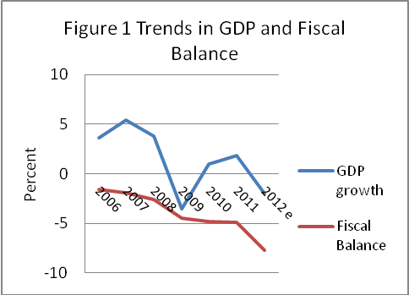
- The subsequent economic recovery was modest, with GDP growing by just one percent in 2010 and 1.6 percent in 2011. While industrial output and exports rebounded and exports to the EU recovered to pre-crisis levels, domestic demand remained deeply depressed. Since then, the economy has faltered again. The year 2012 was particularly difficult for Serbia, marked by political instability (elections at all levels), severe weather conditions (record low temperatures in the winter and a drought in the summer), closure of the largest exporter (US Steel), and the failure of two state banks. Industrial output in 2012 was about four percent lower than in 2011. Energy production alone fell by seven percent). Agriculture output dropped by 17.2 percent in the first three quarters compared to the same period 2011. Overall, the latest estimate for growth in 2012 is -2.0 percent.

- The fiscal balance has also worsened. From 2009-2011, the consolidated government deficit ranged between 4.5 percent and 4.9 percent of GDP. It worsened in the first part of 2012, due to pre-election spending by the previous government and lower collection of revenues. The consolidated general government deficit reached 5.3 percent of GDP in the first eleven months of the year. Consequently the full-year deficit projection has been increased to 6.2 percent of GDP. Adding costs associated with the recapitalization of the failed banks and the clearance of arrears brings the headline deficit to 7.7 percent of GDP.

- The newly formed government has responded by adopting a supplementary budget, with corrective measures on both the revenue and expenditure side. The VAT rate has been increased from 18 to 20 percent. The indexation formula for pensions and public sector salaries has been temporarily set aside and expenditures on both items has fallen in real terms. The Government plans further cost cutting measures in 2013 worth nearly €1 billion. Based on these measures, the 2013 budget targets a deficit of 3.6 percent of GDP. The feasibility of this target remains in dispute, however.

- Due to the sequence of fiscal deficits, Serbia’s public debt level is high and on an unsustainable trajectory. At the end of 2012, the stock of public debt was equal to 61.2 percent of GDP, well above the ceiling of 45 percent set in Serbia’s Law on Fiscal Responsibility. For 2013 it is projected to reach 65 percent of GDP.

- Under these circumstances, it is imperative that the Government find ways to further reduce expenditures. As part of this process, it must find ways to reduce the level of financial support it provides to local governments.

Local Government Fiscal Performance

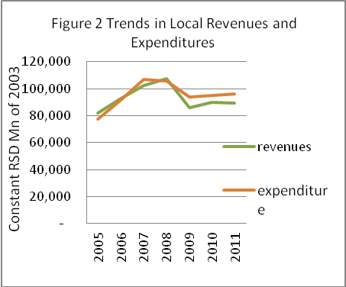
- The aggregate financial performance of Serbian municipalities has fluctuated widely in recent years. As shown in Figure 2, current revenues increased rapidly in real terms in the middle of the last decade, growing 30 percent between 2005 and 2008. Expenditures increased at roughly the same rate, resulting in a small aggregate deficit in 2007 and a small surplus in 2008. With the onset of the fiscal crisis, revenues dropped by 20 percent in real terms. Expenditures fell, but not as rapidly. As a result, municipalities, as a group, ran a deficit equal to nine percent of revenues in 2009. This was largely financed through contractual borrowing. (As discussed below, Belgrade alone accounted for most of the deficit and most of the borrowing.) Both revenues and expenditures recovered slightly in 2010 and 2011. The aggregate gap between revenues and expenditures persisted, however. As a result, municipalities as a group ran a deficit equal to six percent of revenues in 2010 and eight percent of revenues in 2011.

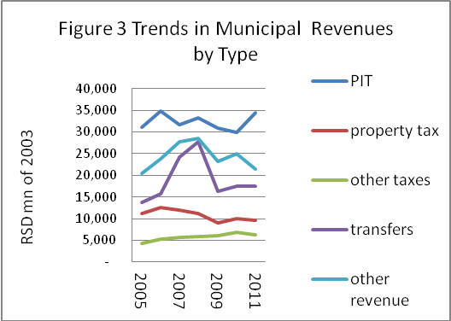
- The fluctuations in revenues over this period largely reflect the impact of government policy. As shown in Figure 3, the rapid increase in revenues in the mid-2000s was largely due to an increase in intergovernmental transfers, particularly after the reform of 2007 which, as noted earlier, guaranteed a level of transfers equal to 1.7 percent of GDP. The subsequent decline reflects the Government’s decision to renege on the new arrangement. In 2009, total transfers from the central government to municipalities (including the equalization transfers and other smaller transfers) dropped not only in real terms but as a percent of GDP: from 1.8 percent of GDP to 1.1 percent of GDP. In 2010 and 2011, the level of transfers remained at 1.2 percent of GDP.

- Trends in other major sources of municipal revenue have, in contrast, tended to parallel changes in GDP. Revenues from the municipal share of the PIT fell slightly, as a percent of GDP, following the local finance reform in 2007, but then remained a constant 2.1 percent of GDP from 2007 through 2010. Revenues from the property tax and other taxes have also tended to parallel changes in GDP. One exception is the category ‘other revenues’, which fell as a percent of GDP, largely due to declines in revenues from land development fees.

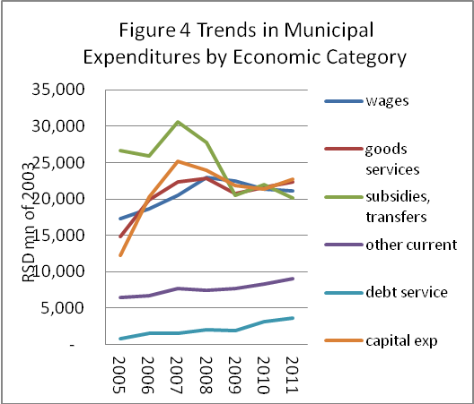
- Until recently, trends in municipal expenditures have generally paralleled trends in revenues. Aggregate expenditures increased sharply from 2005 to 2008 before falling with the onset of the economic crisis. Figure 4 illustrates trends in the major economic categories of expenditure. As shown, capital expenditures accounted for most of the growth in expenditures in the 2005-2008 period, rising rapidly in both absolute and relative terms (i.e., as a percent of municipal expenditure). Between 2005 and 2008, capital expenditures doubled in real terms. Spending on goods and services increased 54 percent. Wages, on the other hand increased by only 33 percent. Expenditures on transfers and subsidies increased only four percent. With the onset of the economic crisis, all categories of spending, (except debt service and ‘other current’) fell in real terms. Subsidies and transfers took the biggest hit, falling nearly 30 percent between 2008 and 2011. Wages fell eight percent. Capital spending fell five percent. (Spending on goods and services fell only two percent.)

- In aggregate, the reductions in expenditures was less than the reduction in revenues. As a result, the aggregate municipal budget balance shifted from a surplus (of two percent of GDP) in 2008, to a deficit of nine percent in 2009, followed by deficits of six and eight percent in the following two years.

- These aggregates misrepresent the situation of most municipalities, however, because they are dominated by the anomalous behavior of Belgrade. In the period following 2008, Belgrade made only minor adjustments in spending. Personnel spending was unchanged in real terms. While ‘other current spending’ fell by 17 percent, capital spending increased by 12 percent. The result was a widening overall budget deficit, which was largely financed through borrowing. Net borrowing (proceeds from borrowing less principal repayments) quadrupled over the period. Because Belgrade represents roughly one-third of aggregate municipal revenues and expenditures, this behavior tends to distort the aggregate picture. Figure 5 illustrates the aggregate fiscal performance of municipalities, excluding Belgrade. As shown, spending in this group of municipalities fell sharply after 2008. As a result, the aggregate deficit of this group of municipalities remained fairly small.

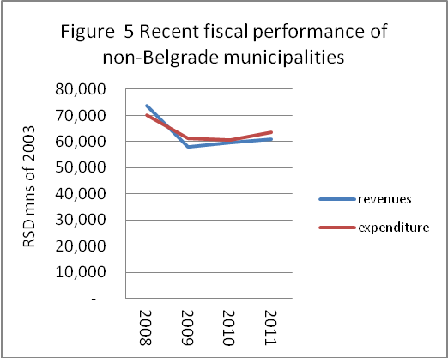
Impact of the Decentralization Law

- The new fiscal decentralization policy is expected to change the revenue situation yet again. As noted earlier, the percent of the payroll tax to be shared with local governments has been increased from 40 percent to 80 percent (Belgrade’s share has been increased to 70 percent) while the amount of the equalization transfers has been reduced according to the ‘development’ category of each municipality. The impact of the amendment is not yet fully apparent in the available budget data. The increase in the municipal share of the PIT went into effect only in October 2011 and the changes to the block transfer system took effect in January 2012. Several attempts have been made to calculate the impact of these changes. Our own calculations, described in Box 2, suggest that the net result will be a substantial increase in revenues for municipalities, particularly compared to the level of revenues from the PIT and block transfers in 2010.

Box 2 Calculating the Fiscal Impact of the Decentralization Amendment

PIT revenues: From 2007 to 2010, total PIT revenues (including both the central and local share) averaged five percent of GDP. It is assumed that PIT revenues will continue to account for this share of GDP in 2012. GDP in 2012 is projected to be RSD 3,476 billion. Total PIT revenues in 2012 are therefore projected to be RSD 174 billion. In 2010, Belgrade accounted for just over half (51 percent) of total local PIT revenues. This share is assumed to continue in 2012. With Belgrade retaining 70 percent of the PIT revenues raised in its jurisdiction, Belgrade’s PIT revenues will therefore rise to RSD 61 billion in 2012. With the other municipalities retaining 80 percent of the PIT, their PIT revenues will rise to RSD 70 billion. Total local PIT revenues will therefore increase to RSD131 billion.

Block transfers: The decentralization amendment implies two changes in the system of block transfers. First, the amount of the transfer to each jurisdiction is reduced according to that jurisdiction’s level of development. The aggregate fiscal impact of this clawback—the reduction according to each municipality’s level of development-- cannot be determined with the data at hand. The Ministry of Finance (MOF) estimates it to be equal to 0.7 percent of GDP. Second, the transfer would be fully funded. Fully funding the equalization transfer in 2012 would imply an increase in initial basis for calculating the distributable pool to 1.7 percent of GDP. After applying the clawback, the amount of the block transfer in 2012 would be equal to one percent of GDP or RSD 35 billion. This is just slightly less than the actual amount transferred in 2011: RSD 38 billion.

On this basis, revenues from the PIT and block transfers are projected to total RSD 165 billion in 2012, or roughly RSD 71 billion more than in 2010, the last full year prior to the decentralization amendment. As a percentage of GDP, revenues from these two sources would increase from 3.1 percent in 2010 to 4.7 percent in 2012.

- There are of course winners and losers under the new law. Who wins and who loses (and by how much) depends on the scenario with which the outcome is compared. Comparing the outcome with the amounts that would have been transferred under the original legislation yields one set of winners and losers; comparing it with amounts that were actually transferred to individual jurisdictions after 2008 yields another. Under either alternative, Belgrade emerges as a clear winner. Its share of the PIT increases from 40 percent to 70 percent. Although it receives no block transfers under the new arrangement, it was, in fact, receiving very little in the years before 2012: RSD 3.3 billion in 2010; RSD 3.2 billion in 2011. Overall, Belgrade’s revenues would increase by 28 percent compared to the original legislation and 35 percent compared to the amount actually received in 2010. The other municipalities, as a group, would also gain, but less spectacularly. Although their share of the PIT would double, the size of the non-categorical transfers would decline by 0.7 percent of GDP. The result, for these municipalities, would be a gain of 11 percent compared to the original legislation, and 18 percent compared to the amount actually received in 2010.

- Within this group of municipalities there are also relative winners and losers. For an individual municipality, the extent of any gain or loss will depend on the extent to which the gains from the doubling of the PIT are offset by reductions in block transfers. Jurisdictions with strong PIT tax bases will, of course, gain the most. The impact of the clawback provision is more difficult to determine. As noted earlier, the block transfers are currently used, first, to bring the per capita shared-tax revenues of poorer jurisdictions up to ninety percent of the national average. Any remaining amount is essentially distributed among all municipalities on the basis of population (65 percent) and land area (about 20 percent).

- The clawback provision adds a further complication. As noted above, municipalities falling into all but the lowest development category receive only a fraction of the transfers to which they would otherwise be entitled. The clawback is likely to have little impact on the equalization component of the transfers. Because shared-tax revenues are presumably correlated with level of development, the more developed municipalities are likely to have per capita revenues over 90 percent of the national average. As a result, they will not be eligible for the equalization component of the block transfers to begin with. The least developed municipalities, by the same token, are likely to have revenues less than 90 percent of the national average, but will be permitted to keep 100 percent of the equalization transfers to which they are entitled. The impact of the clawback provision is, however, likely to be considerably greater on the general transfer component. The relative importance of these two components of the transfer distribution formula is difficult to determine with the data at hand. Rough estimates, nevertheless, suggest that the general fund component is far more important than the equalization component. As a result, the burden of the clawback provision is likely to fall more heavily on the most developed municipalities. These are presumably the same municipalities that gained the most from the increase in the municipal share of the PIT. But the correlation is likely to be weak.
- The biggest loser in the whole scheme is, of course, the central government. Compared to the situation in 2010, it stands to lose 40 percent of PIT revenues and gain virtually nothing from the changes in the transfer system. (The gains from the clawback provisions will be offset by the Government’s decision to fully fund the transfer.) The net effect on the central government will be a decrease in resources equal to 1.3 percent of GDP.
Table 4 Impact of Decentralization Law
Projected revenues from PIT and equalization transfer, 2012
RSD mn
 | basis of comparison
 | original law | actual 2010 | new law
TOTAL | 128,612 | 122,366 | 165,110
Belgrade | 34,760 | 33,757 | 60,830
Other muns | 93,852 | 88,609 | 104,280

Do Local Governments Have Too Much Money?

- This report is intended to focus on the issue of greatest immediate concern to the Government: the fiscal deficit. Since the onset of the economic crisis, the consolidated fiscal deficit has grown from 2.6 percent of GDP (in 2008) to 6.8 percent of GDP in 2012. In principle, the Government could reduce the central government deficit by reducing the municipal share of the PIT, reducing equalization transfers, or offloading certain central government responsibilities onto the local level. Provided municipalities do not respond by increasing borrowing on their own, the consolidated deficit would shrink as well.

- Whether this makes sense requires an answer to the question : do local governments have more money than they need? At the outset, there is a temptation to think so. Under current revenue sharing arrangements, the central government transfers the vast majority of personal income tax revenues to the municipalities and funds the block transfer. It also permits considerable local leeway over the level of fees and considerable latitude in administering the property tax—neither of which the municipalities fully exploit. At the same time, the central government continues to finance the costs of high-ticket items, such as the salaries of teachers and primary health care providers, that are sometimes financed through local government budgets in other European countries.

- Nevertheless, it is a difficult question to answer. It involves a more fundamental question: how much should the Serbian public sector as a whole spend on the functions assigned to local governments? Should the Serbian public sector spend more on urban infrastructure and less on pensions? If so, then the scale of transfers and tax sharing should be increased. It would also require a calculation of the appropriate costs of the services assigned to local government. Attempts have been made (in other contexts) to estimate the ‘costs’ of such services but with few useful results. Costs depend upon standards. The cost of achieving high standards in one sector must be weighed against the costs of achieving high standards in another—including sectors falling under the responsibility of the central government.

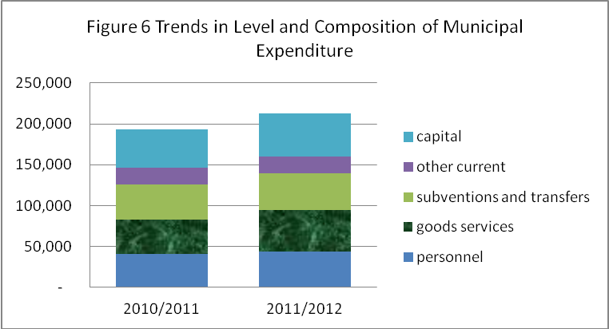
- Another approach, which has been widely used in Serbia, is to designate a particular point in time in Serbia’s recent fiscal history as a golden age and treat all changes since that time as steps in the wrong direction. Partisans of municipal interests tend to pick 2008—the year in which block transfers were fully funded and municipal revenues peaked in real terms--as the golden age. Partisans of the central government pick 2009, 2010, and or the first three quarters of 2011—ie., the period after the Government began to underfund the equalization transfer but before the decentralization amendment went into effect. Both sides can site subsequent trends in the economic composition of local expenditure as evidence to support their view. Partisans of municipal interests point to the decline in capital spending after 2008. Partisans of the central government look to more recent trends. Figure 6 compares the level and composition of municipal expenditure before and after the decentralization amendment went into effect. (Because municipal expenditure data is available only through August 2012, the chart compares spending in the eleven-month period from October 2011 to August 2012 with same period in the preceding year.) As shown, total expenditures increased by ten percent in real terms between the two periods. The largest single category of expenditure increase was ‘goods and services (19 percent), followed by ‘capital’ (nine percent). Personnel spending increased seven percent. This is not a clear indicator of anything, however. Part of the increased spending on goods and services, for example, may represent the payment of arrears to suppliers—a salutary and prudent use of funds. Part of the increase in capital spending may represent the acceleration of projects delayed by budget cuts in the previous two years. On the other hand, the increase in personnel spending may represent an increase in overstaffing or excessive levels of compensation.

- Comparisons with other European countries are marginally more useful. As a percent of GDP, total municipal spending is lower in Serbia than in most of its neighboring European comparators. Figure 6 shows the level of municipal spending, as a percent of GDP, in Serbia and the ten New Members States (NMS) of the EU. As shown, Serbia ranks second-to-lowest. But the level of local government spending would be expected to vary according to the functions assigned to local governments in each country. In countries where local governments pay for teachers’ salaries, health care costs, or social assistance programs, the level of local spending would be expected to be higher than in countries where the central government pays bears these fiscal burdens. The breakdown of municipal spending by function, shown in Figure 6, allows a slightly more precise comparison of spending levels among countries. The segments of each bar shows the level of municipal spending in each country on education, health, social assistance, and ‘other’. If spending on the three social sectors is excluded, the level of municipal spending in Serbia appears to be fairly typical of its NMS neighbors. Serbian municipal expenditures on ‘other’ are equal to 4.8 percent of GDP, just 0.2 percentage points over the median for the new NMS countries. Data for Serbia is from 2010—i.e., before the decentralization amendment went into effect. If it is assumed that the increase in municipal revenues arising from the decentralization amendment is entirely devoted to the ‘other’ category, spending in this category would rise to 5.3 percent of GDP, a figure comparable to the levels in the Baltic NMS (Estonia, Latvia, and Lithuania). This does not, of course, prove that the level of resources allocated to subnational governments is right. International comparisons do not reflect best practices, but rather the outcome of years, if not decades, of adjustments and compromises.
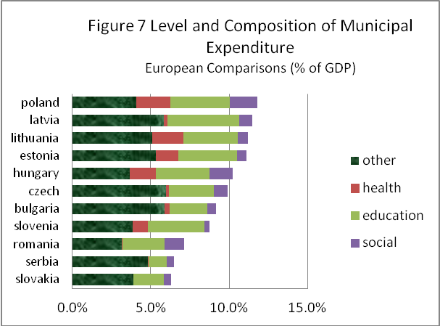
- One last approach to the question is to look at suspect categories of municipal expenditure—spending that appears wasteful or extravagant. Two appear promising. The first is the municipal wage bill. Local governments employ approximately 60,800 public servants in local administrations and another 75,000 in their utility companies. As shown earlier in Chart 4, the municipal wage bill (covering only employees directly employed by municipal administrations) increased 33 percent in real terms during the boom years (2005-2008) and then fell by eight percent over the following three years. Since the decentralization amendment went into effect, the municipal wage bill has increased by seven percent in real terms.

- In principle, central government regulations should restrain growth in the local wage bill. The central government presently imposes controls over both the number of local government employees and the level of their salaries. Current legislation sets a ceiling of four local government employees per thousand inhabitants. This cap broadly applies to ‘local government bodies and other institutions financed by local budgets’ but exempts those providing education (including preschool) and health institutions, and, most importantly, public enterprises. Municipalities with fewer than 15,000 inhabitants and those that derive less than 20 percent of their revenues from central government transfers are required to reduce staff by only 50 percent of the number that would otherwise be required. Municipalities are also allowed to finance staff in excess of the ceiling from their ‘own resources’. According to the explanatory material accompanying the law, local governments employed an average of 5.03 staff per thousand inhabitants at the time the law was enacted. The law therefore implied an average reduction of 20 percent, with staffing reductions in all but 35 Serbian local governments. The law was intended to go into effect at the start of 2010. Local governments with staff numbers in excess of the ceiling were required to adopt new job systematization acts by December 31, 2009. Those failing to reduce staff numbers by that date were to suffer proportionate cuts in central government transfers. As the law was not enacted until late December, none of these provisions were immediately implemented. It is reported that the law is now in effect and that certain municipalities have in fact seen their transfers reduced for failing to comply with the ceiling. But it is also reported that local governments have evaded the caps by exploiting the ‘own resources’ loophole; declaring that staff in excess of the ceiling are in fact financed from service fees and administrative charges.

- The central government also attempts to control the level of municipal wages. The Law on Wages in Government Agencies and Public Services sets out specific parameters for the salaries for local elected officials and authorizes the Government to establish wage coefficients for local government public service employees. As is the case with central government employees, individual wages are determined by multiplying the individual coefficients by a base salary which applies to all public employees and is periodically adjusted. In April 2009, the Government instituted a wage freeze on all public employees, in effect, freezing the base salary at its April 2009 level. The freeze was maintained through 2010. In January 2011, the Government increased salaries by two percent and adopted a policy of indexing subsequent pay increases to inflation and one-half the growth rate of GDP. Regular semi-annual indexation of public wages began in April 2011, based on the rate of inflation during the previous three months and one half of real GDP growth rate in 2010. The October 2011 adjustment was based on inflation over the previous six months. Given the low (one percent) rate in real GDP growth in 2010, real growth in individual salaries should have been minimal since the freeze went into effect. There is evidence however that (like the cap on personnel) the central government wage controls have been evaded. According to the State Auditor, Belgrade recently increased the base salary that applies to its employees in direct violation of the law. The Government responded by issuing a decree rolling back the increase in the base salary but retroactively increasing the coefficients for Belgrade staff by a corresponding amount—thus legalizing the action.

- This issue will be addressed in further detail in the follow-on, second, phase of this task. Phase 2 will analyze the size of the existing municipal labor force, documenting trends over time and drawing on comparisons with other European countries. It will also analyze prevailing levels of compensation, again in comparison with other European countries as well as with salary levels in the Serbian private sector. It should be emphasized that even if municipalities are overstaffed or staff are overcompensated, reducing local payroll expenses will not, by itself, help reduce the government fiscal deficit. Cutting the municipal payroll does not reduce the fiscal burden that municipal governments impose on the central government. It merely reduces a certain category of municipal spending—freeing municipalities to spend on something else.

- Municipal subsidies are a second suspect category of expenditure. Not all subsidies are suspect, of course. Certain kinds of subsidies are economically justifiable. Public transport subsidies, for example, can encourage public transit use as part of a traffic management strategy. Targeted utility subsidies can be a means of enabling lifeline service for low income households. But subsidies can also be a means to avoid charging economic prices for services. Or subsidizing inefficiency.

- In Serbia, the scale of local government subsidies—justifiable and unjustifiable—is difficult to determine. The Serbian system of budget classification does recognize subsidies as a separate economic category of expenditure. According to the March 2012 Bulletin of Public Finance, such subsidies accounted for ten percent of aggregate municipal expenditure in 2011. But this figure is not particularly meaningful. On one hand, it includes subsidies to enterprises such as road maintenance companies that have no revenue of their own (and thus are justifiable recipients of budget support). On the other hand it excludes budgetary expenditures on capital investments in water supply, sanitation, district heating and other utilities; expenditures that might more appropriately be financed from municipal enterprises. The scale of subsidies to major utilities and public transport is examined in the next chapter of this report.

Directions for Reform

- The available evidence does not provide a definitive answer to the question: do municipalities have too much money? As discussed above, the evidence from trends in municipal spending is ambiguous. While the decline in municipal revenues between 2008 and 2012 is clearly reflected in a drop in (presumably worthwhile) capital spending, it is not clear whether the recent increase in municipal PIT revenues has been put to good use or not. International comparisons, for their part, suggest that the level of municipal spending in Serbia is not out of line with the new member states of eastern Europe—although the recent increase in the municipal share of the PIT will put Serbia nearer the upper end of the range. Preliminary evidence suggests that administrative staffing levels and compensation are not excessive—or at least not inconsistent with central government regulations. (Although levels of staffing may be excessive in municipal utility enterprises, the absolute numbers are not large.)

- Despite these ambiguous results, one conclusion is clear. During the current fiscal crisis, both levels of government must cut back. Reductions in central government spending must be accompanied by reductions in local government spending. The question is how. Several routes present themselves. One is to reduce the level of central government fiscal support to municipalities. A second is to increase their expenditure responsibilities.

Reducing Central Fiscal Support

- By far the most straightforward way to reduce local resources would be to reduce the share of the PIT that is retained by the municipalities. The system of local finance established by the 2007 reform had much to recommend it. The system of PIT sharing ensured that municipalities had an instrument with which to tax themselves, while the equalization element of the block transfer ensured that even municipalities with weak PIT tax bases had at least a minimum level of revenue. The level of tax sharing may have been too low. There is no a priori reason for settling on 40 percent. But neither is there a priori justification for 80 percent. But if the overriding aim is to shift the balance of public resources in favor of the central government, the most straightforward approach would be to reduce the municipal share from the current 80 percent to a lower proportion.

- An alternative (or complement) to this reform would be to reduce the level of block transfers. Rather than finance them at one percent of GDP (net of the clawback), the Government could finance them at, say, 0.5 percent of GDP. The rough calculations cited earlier suggest that under this reduced proportion, sufficient resources would remain to fully fund the equalization component of the transfer system. It is the general transfer (the one allocated on the basis of population and land area) that would take the hit.

- The distributional implication of these two alternatives are, unsurprisingly, very different. Reducing the PIT share would hurt Belgrade. Reducing block transfers would hurt the poorest (‘least developed’) municipalities. It is not obvious that Belgrade should be the jurisdiction to suffer. Belgrade is the geographic heart of the Serbian economy. If cutting the municipal share of the PIT means depriving Belgrade of the resources needed to make key infrastructure investments, a more geographically dispersed distribution of the burden might may make more sense.

Decentralizing Expenditures

- Rather than doing either of these things (reducing the local share of the PIT or reducing the level of transfers) the Government is instead pursuing remedies on the expenditure side; attempting to offset the recent increase in municipal revenues by a corresponding transfer of expenditure responsibilities. Roads are the initial target. Five thousand km of regional roads, previously a responsibility of the republic public enterprise, Roads of Serbia, are to be transferred to the municipalities. In principle, this would represent a significant offloading of expenditures. The Fiscal Council estimates that the transfer would cost municipalities RSD 10 billion in annual maintenance expenditures. This is, however, only a small fraction (15 percent) of the windfall represented by the increase in the municipal share of the PIT. Even so, the move has been resisted by the municipalities. In Belgrade, the 400 km of roads that were to be transferred remain in bureaucratic limbo. According to the city’s transport department, the regulations explicitly transferring the roads to the municipality have not yet been issued. Kragujevac municipality claims it does not even know which roads are to be transferred to it. To induce the municipalities to assume responsibility for the roads, the central government proposes to allocate RSD 4 billion in the 2013 budget to compensate municipalities for the cost of maintaining these newly-decentralized roads. In effect, the central government will be paying twice for the decentralization of road maintenance; first, through the increase in the municipal share of the PIT and second, through the RSD 4 billion to be used to induce municipalities to accept responsibility for maintaining them.

- Whatever its contribution to reducing the central government deficit may be, the proposed decentralization of roads leaves much to be desired as a strategy for rebalancing central and local resources. As noted earlier, it is Belgrade that stands to gain the most from the decentralization amendment, followed by other jurisdictions with strong PIT tax bases. There is no reason to believe that these same jurisdictions will bear the fiscal brunt of road decentralization. In fact it is more likely that rural jurisdictions, with low population densities, will be forced to take on a disproportionate share. As a result, the decentralization law, combined with the road decentralization, will produce random windfalls for some jurisdictions and severe fiscal distress for others.

- Another idea is to require municipalities to pay a share of the salaries of the teachers in their jurisdictions. This idea is also ill-advised, although its specific drawbacks will depend on how it is implemented. One approach would be to require all municipalities to pay a uniform share of the salaries of the teachers in their jurisdiction. This will result in the same sort of arbitrary distribution of winners and losers that road decentralization would. In this case, the burden would fall disproportionately on jurisdictions with relatively large numbers of teachers. These are likely to be in rural areas, where declines in the school age population have not yet been matched by declines in the number of teachers. A variant of this approach would focus the burden explicitly on municipalities whose schools have excessively high teacher: pupil ratios. Under this approach, the state would continue to pay the salaries of teachers in classes that meet minimum size standards. Teachers in under-enrolled classes would have to be paid by the municipality. But this would again result in an arbitrary distribution of winners and losers, with rural municipalities concentrated in the latter group. The only equitable way to implement this approach would be to set each municipality’s contribution to teachers’ salaries at a fixed percentage of its PIT revenue. This would be an extraordinarily complex means of achieving the same result as a simple roll back in the percentage of the PIT retained by municipalities.

Raising Local Revenues

- Critics have also argued that the fiscal deficit could be reduced by forcing local government to rely on their own revenue sources. In theory, this could permit the central government to scale back the municipal share of the PIT or the size of the block transfer, without necessarily decreasing the level of municipal resources. It should be noted that this strategy would increase the aggregate tax burden on the Serbian economy. An increase in local property tax revenues, for example, increases the aggregate tax burden just much as an increase in the central government VAT rate does. But raising taxes is one way to reduce the deficit, and raising local taxes is one way to do so.

Property Tax

- In principle, the urban property tax, along with its companion fee for the use of urban land, would appear to be a promising candidates. They are the largest sources of tax revenue over which municipalities exercise any policy control.

- The yield of the property tax is a function of four factors. The first is the completeness and accuracy of the data on the characteristics of the tax base. Land parcels may be missing from the tax rolls, or be inaccurately measured. Data on improvements (e.g., buildings) may be missing, inaccurate, or out of date. Information on ownership may be incorrect. In Serbia, the tax authorities rely on self declarations to discover properties and determine their characteristics. Property owners (or users) are required to file declarations with the tax administration authorities. But the law does not provide specific penalties for failure to file a tax declaration and under-declaration is said to be widespread. One way to address this would be through stepped up field surveys. (Some municipalities have attempted to do so by hiring temporary staff off the unemployment registry. They proved unequal to the task.) Another way is to cross-reference data from other sources, such as electricity bills. In Arandjelovac, for example, there are reportedly 21,000 electricity consumers but only 9,500 property taxpayers. In the Americas, some countries have gone so far as to map each parcel of land. This ensures that all land (but not all buildings) are accounted for, but can be highly expensive.

- The second factor is the method that is used to value property. In Serbia, the property tax law sets out three methods for determining the value of property for tax purposes. In the case of property owned by physical persons, the market value is determined by applying ‘basic’ and ‘adjusting’ elements. The basic elements are: (1) the floor area of the building and (2) the average market price per square meter of similar buildings in the same municipality. This latter amount is determined by the Statistics Office of Serbia on the basis of real estate transaction data. The adjusting elements are: (1) the location of the property; (2) its quality and (3) ‘other elements affecting its market value’. In the US and other countries that rely on the property tax to support local governments, such formula-based appraisal has proven highly successful in the valuation of common types of property (single family and multi-family homes, standard commercial buildings) although it depends critically on the accuracy of the factors used to convert physical characteristics to estimates of market value.

- In the case of properties owned by legal persons (i.e., companies), the value is defined as the book value of the property. As book values are based on initial purchase prices and are subject to depreciation, the valuations on these properties are far below their actual market values.

- The third method of valuation applies to agricultural and forest land. According to the law, the value of this category of property is to be five times the annual cadastral income from that land, according to the latest data available to the organization in charge of land registries. According to representatives of some municipalities interviewed for this report, these values were last calculated in 1994 (when one dinar was equal to one D-mark) and have never been updated. As a result, valuations are trivial.

- The third factor affecting the yield of the property tax is the tax rate. Current tax rates in Serbia are relatively low. The maximum tax rate for corporations is 0.4 percent. For property owned by physical persons, the maximum rate on land is 0.3 percent. The rate on buildings is progressive: 0.4 percent on the first RSD 10 million of value; 0.6 percent of the next RSD 15 million of value, one percent on the next RSD 25 million, and two percent on any value over RSD 50 million. By comparison, the rate of the Hungarian land and building taxes is three percent or HUF 900 per square meter for land and HUF 500 per square meter for buildings (equivalent to USD 4.10/m² and USD 2.27/m² respectively). Rates in the UK (specifically, rates on residential property in England and Scotland) vary by jurisdiction and are based on their value as of April 1991. Properties are grouped into bands. In Norwich, for example, residential properties in the lowest band (valued at less than £40,000) pay £1,045. Properties in the highest band (valued at over £320,000) pay £3,135. This is equivalent to a minimum rate of 2.6 percent for properties in the lowest band and a maximum of one percent for properties in the highest band.

- The fourth factor is the collection rate—the proportion of the billed amount that is actually collected. This is often the Achilles heel of property tax reform. Much effort is expended on improving the coverage of the tax base and the accuracy of valuation. But if local political leaders lack the courage to crack down on delinquent accounts, these efforts have little impact on actual revenues. Preliminary data suggests that, in Serbia, collection rates on property owned by physical persons are relatively high, but that collection from legal persons is subject to many complications arising from company restructuring and privatization. Political factors also appear to be a constraint. In Serbia, local governments have the authority to seize and sell properties but does not use it—at least not on big property owners.

- Efforts to increase property tax yields could logically focus on all four of these factors. Missing land parcels could be brought onto the rolls. Data on the physical characteristics of buildings could be updated. The unit values assigned to the floor area and ‘adjusting factors’ used in valuing property owned by physical persons could be made more accurate. Tax rates could be increased. Collection enforcement could be improved. One of the most attractive targets is property owned by legal persons. Here, both the valuations and the tax rates are low. It should be recognized that the valuation of some such properties can be technically difficult. Sophisticated manufacturing equipment cannot be accurately valued on the basis of a few physical characteristics. Private property valuers may have to be retained. If the rate on company-owned property were raised above the current trivial rate, however, the resulting revenue might justify the expenditure.

- There are reasons to view the prospects for the property tax cautiously, however. The property tax--and particularly the property tax on owner-occupied housing—is politically sensitive. Among European countries, only one—the UK--manages to raise more than 2.5 percent of GDP from it. Countries that are certainly technically capable of imposing a sophisticated property tax—Sweden, Germany—prefer to rely on other sources. (See Figure 8.) In Serbia, recurrent property tax revenues in 2011 were equal to 0.4 percent of GDP. In technical terms, this could certainly be increased. But significant increases in property tax revenues will also require municipal governments to overcome political constraints.
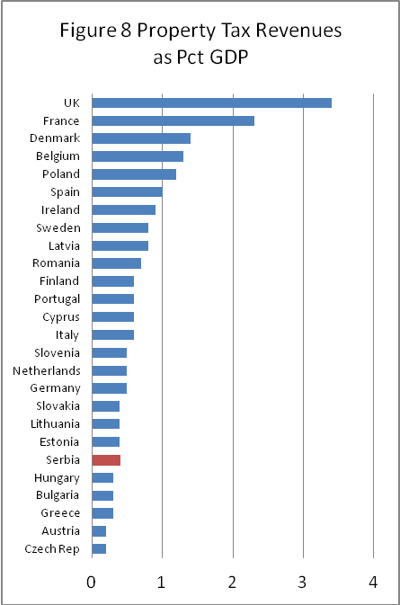

Other Revenue Opportunities

- Municipalities could also generate revenue by better exploiting their role in land development. One route would be to increase the level of land development fees in outlying areas. As noted earlier, development fees (at least in Belgrade) fail to cover the cost of providing new network infrastructure on the urban fringe. According to the Ministry of Finance, a new law is under preparation that would link the amount of the development fee more closely to the actual cost of providing infrastructure to the site, as part of a new law on fees and charges for the use of public land. This is a good idea. The Government should also reconsider its proposal to cap the amount of the development fee for illegal buildings at €100. Many owner-occupants can presumably afford to pay far more than this and can be induced to do so through stepped up enforcement of existing legislation. Such opportunities are presumably scarcer in rural municipalities, where there is less demand for development. Serbians who were born in rural areas but have since moved to cities or abroad are said to be building illegal houses in their home villages, but the prospects for charging them land development fees are said to be nil.

- Some municipalities could also generate considerable income through the sale or lease of land they own outright. Belgrade, for example, owns land (which it acquired through the purchase of a defunct agro-kombinat (food production company) near the site of the new bridge over the Danube. This will presumably have considerable value once the bridge is completed. Kragujevac, on the other hand, has largely exhausted the supply of unclaimed state land within the designated urban zone of the municipality. (Large parcels are claimed by the military.) Nevertheless, the city has the to expand the urban zone onto vacant state land on the city’s periphery (currently zoned for agriculture) land and then selling or leasing it.

Cutting Subsidies to Municipal Enterprises

- In principle, municipalities could also generate additional revenues by increasing the tariffs on the services they provide. Water supply, district heating, and public transport all appear to be promising candidates. While these increases would not directly generate revenues for the municipalities, they would reduce the need for budget subsidies to municipal enterprises or capital expenditures on their behalf. In principal, tariffs could be set high enough to contribute to the costs of capital investments in these sectors.

- Municipalities carry out much of their work through municipal enterprises. The Law on Public Enterprises (Article 4) allows municipalities to establish public enterprises in a wide variety of sectors; in fact, in any sector ‘that is important to the general activities of the local authority’. According to Agency for Business Registers there are 645 active local public enterprises, of which 348 are public utilities. As shown in Table 5, water utilities account for about one-quarter of the total, solid waste management companies about ten percent, and district heating and urban transport companies six percent and four percent respectively. The remainder are engaged in a wide variety of activities, including radio and television broadcasting, urban planning services, building demolition and the maintenance of green areas. In terms of scale, the four utility sectors dominate. According to the financial reports submitted by the enterprises, the four sectors account for about 75 percent of the total operating revenues of all municipal enterprises and 75 percent of total employment. Within this group, district heating companies account for about 30 percent total operating revenues but only nine percent of employment.
Table 5. Number of Municipal Enterprises, by Sector
Sector | N | %
Water | 151 | 23%
SWM | 67 | 10%
Dist heating | 40 | 6%
Transport | 27 | 4%
SUBTOTAL | 285 | 44%
Radio/tv | 64 | 10%
Urban plng | 56 | 9%
Demolition | 35 | 5%
Parks | 26 | 4%
Roads | 22 | 3%
Property mgmt | 21 | 3%
Sports | 19 | 3%
Other | 115 | 18%
TOTAL | 643 | 100%
Source: Municipal Enterprise Financial Statements (PUC mini-data base)
- Water companies account for 22 percent of operating revenue but 32 percent of employment. The respective shares of the solid waste management and transport companies are shown in Table 6. In total, the operating revenues of municipal enterprises total 4.4 percent of GDP.

- Available evidence suggests the financial performance of municipal utilities varies considerably among sectors and individual municipalities. In strictly financial terms, 19 of the 40 district heating companies showed significant losses (net losses greater than 0.5 percent of operating revenues) in 2010 and even this may understate the extent to which tariff revenue fails to cover operating costs, as municipal operating subsidies are generally classified as revenues. (As noted earlier, most capital investments are financed directly from the municipal budget and do not count as company expenditures at all.) Sixty of the 145 water companies for which data are available had significant losses. Only four of the 25 transport companies had significant losses, but this is presumably because municipal operating subsidies were classified as revenues. Twenty of the 63 solid waste management companies reported significant losses.
Table 6 Revenues and Employment in Largest Municipal Enterprise Sectors (2010)
 | Operating Revenues |  | Employees |  | Pct w/ significant losses
 | RSD mn | Pct of All Companies | No. | Pct of All Companies | Pct w/ significant losses
District heating | 36,634 | 29% | 5,241 | 9% | 48%
Water | 28,419 | 22% | 19,019 | 32% | 41%
SWM | 14,614 | 11% | 11,199 | 19% | 32%
Transport | 17,226 | 14% | 10,626 | 18% | 16%
SUBTOTAL | 96,893 | 76% | 46,085 | 77%
TOTAL | 127,370 | 100% | 59,575 | 100%
Source: Municipal Enterprise Financial Statements (PUC mini-data base)
- Subsidies to municipal enterprises, at first glance, appear to be fairly costly to their municipal owners. According to the survey of 14 municipalities, subsidies to enterprises consumed 16 percent of Belgrade’s budget, 13 percent of the budgets of the other three large cities and six percent of the budgets in the sample of ten smaller jurisdictions. This is not necessarily indicative the level of funding that could be raised from tariffs, however. The figure includes subsidies to municipal enterprises that would not be expected to raise their own revenues. Road construction companies, for example, would not be expected to be self-financing. Even in the case of enterprises that do impose tariffs, it is not necessarily indicative of potential savings. As noted earlier, a high level of subsidies may also reflect deliberate policy decisions; e.g., policies aimed at reducing costs to low income households (particularly in the case of district heating) and to encourage the use of public transport (in the case of subsidies public and private transport operators).

Water Supply

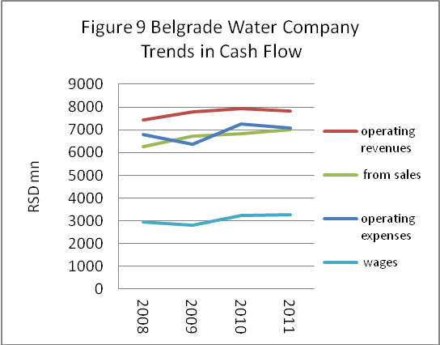
- Serbia has 151 water companies that are organized as municipal enterprises. The Belgrade Waterworks and Sewerage Company is by far the largest of them. Judging from its financial statements, the company appears to have engineered a significant financial turnaround over the last four years. According to figures cited in the PEDPL program document, the company reported losses totaling € 54.2 million in 2007, or about 37 percent of total expenditures. More recent income statement data suggests the company made a small profit in 2011: RSD 9.7 million on total revenue of RSD 7,874 million. The most important contributor to the improvement appears to have been a decline in expenditures on amortization and depreciation, which fell from RSD 4.4 billion in 2008 to RSD 1.5 billion in 2011. This may misrepresent the company’s financial condition, as depreciation is an accounting (rather than cash) expense. The company’s cash flow statement may be a more accurate indicator of its financial condition. Figure 9 illustrates trends in the company’s cash flow over the last four years. As shown, operating revenues have exceeded operating costs by about ten percent over the last four years (except 2009, when the margin increased to 22 percent). Revenues from the sale of water accounted for 85 to 90 percent of total operating revenues over that period. The remainder appears to consist of subsidies from the municipal budget. This suggests the company’s tariff revenues have been roughly sufficient to cover its operating costs in cash flow terms.

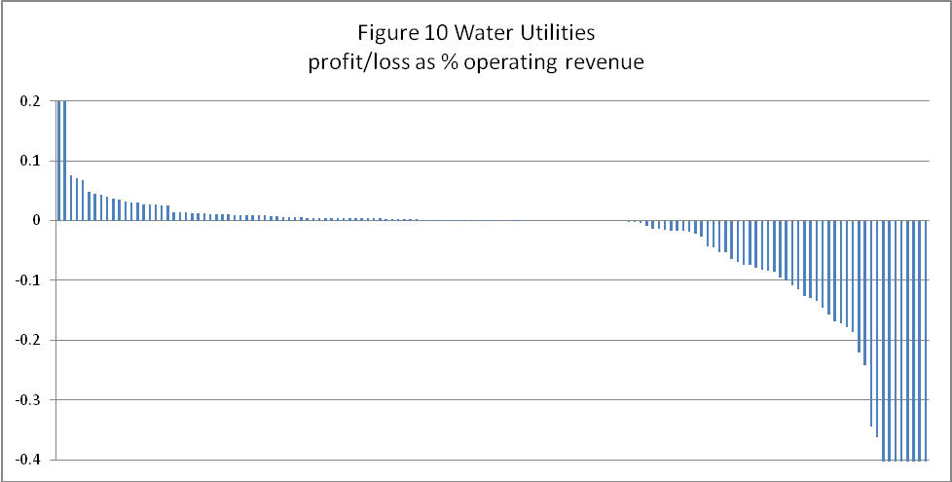
- The financial performance of water utilities in the rest of the country is mixed. As noted above, sixty of the 145 water companies for which data is available had significant losses in 2010. In general, larger companies (measured in terms of operating revenue) were more profitable than smaller ones. (Among the 145 companies, operating revenue is positively correlated with net profit. r= 0.17). In 2010, Belgrade, Novi Sad, and Kragujevac all reported profits. Of the four largest municipalities, only Nis reported a loss. As shown in Figure 10, the vast majority of the 145 water companies were near the break-even point.

- Some indication of the reasons for these variations in financial performance is provided by an IBNET benchmarking study sponsored by the World Bank. Regrettably, IBNET has limited coverage. It covers only the 15 municipalities that were willing to participate in the study. This includes some of the larger ones (Novi Sad, Subotica) but not does not include Belgrade, Nis, or Kragujevac. The published IBNET report does not show the profit or loss of each company (either in the income statement sense or in the cash flow sense) but it does show factors that would contribute to it. Three indicators are particularly telling. The first is the percentage of non-revenue water. This is the difference between the amount of water that is produced and the amount that is sold. These discrepancies can be due to technical losses (e.g., leaks) or administrative losses (e.g., illegal connections). (Non-revenue water does not, however, reflect, collection performance.) The IBNET data reveals a wide variation in performance among individual companies. As shown in Figure 11, the percentage of non-revenue water is over 60 percent in Raska, Sjenica, and Novi Pazar, but less than 25 percent in Novi Sad, Vrbas, and Bac. The second telling indicator is staffing levels. These range from around two per thousand connections in Sjenica, Subotica, and Bac to seven per thousand connection in Novi Sad and 13 per thousand in Leskovac. The third is tariff levels. These range from RSD 22 per cubic meter in Snjenica to RSD 50 per cubic meter. This suggests is that even within existing regulatory framework, much improvement is possible.

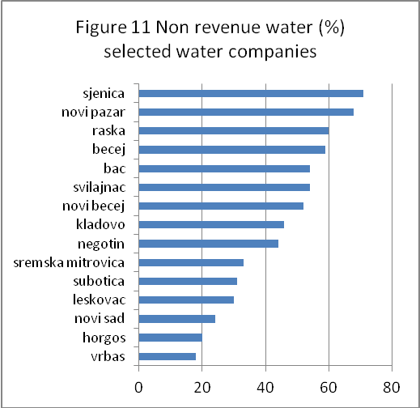
- What can be done? The most readily available solution to the financial difficulties of the water companies would be to increase tariffs. In principle, municipalities have considerable autonomy over the level of water tariffs. Requests for tariff increases are normally submitted to the municipal council annually by each enterprise. These must then be approved by the local council and submitted to the Ministry of Trade, where they are checked for consistency with existing legislation. Starting in 2004, the Ministry of Finance imposed a ceiling on tariff increases, prohibiting increases above the projected inflation rate. This had an adverse impact on the financial condition of many municipal enterprises. Although the inflation cap reportedly remains in place, substantial increases in public utility tariffs have recently been reported. According to IBNET data, Novi Sad increased its water tariff from RSD 21 per m³ in 2009 to RSD 38 per m³ in 2010 and RSD 50 per m³ in 2011—an increase of 140 percent. Cumulative inflation over the two year period was only 18 percent, according to the NBS August 2012 inflation report.

- The problem with this approach is that it merely allows water companies to pass along the inefficiencies of their operations onto consumers. The evidence above suggests there is plenty of room—at least in the most inefficient water companies—to reduce costs instead. This could be accomplished, for example, by reducing excess staffing, improving leak detection (to reduce technical losses), cracking down on illegal connections, and improving collection enforcement. It could also be accomplished by extending metering in multi-family housing to individual units. At present, water consumption is metered for the building as a whole, but not for individual units. Instead, each apartment’s share of the total is prorated, based on its floor area. Metering individual units would presumably cut down on individual household consumption, reducing the volume of water that the utility must produce and distribute.

District heating

- District heating services are largely confined to residential and commercial consumers in large Serbian cities. According to Household budget survey figures, only twenty percent of Serbia’s three million households has district heating. The service is provided by approximately 60 district heating companies, owned by municipalities, and organized as public enterprises.
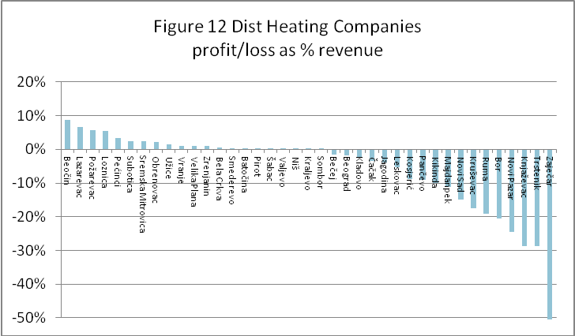
- The financial performance of the companies varies considerably. According to a recent (2012) study by the Ministry of Regional Development and Local Government, 30 companies were profitable in 2010, while 26 companies operated at a loss. (Two of the surveyed companies did not report financial results.) More detailed data on the financial performance of individual companies is provided by PUC data base, albeit with more limited coverage. Of the 40 companies included in the PUC data base (including Belgrade and Novi Sad), 22 reported profits in 2010. Eighteen reported losses. As shown in Figure 12, the scale of losses far exceeded the scale of profits.
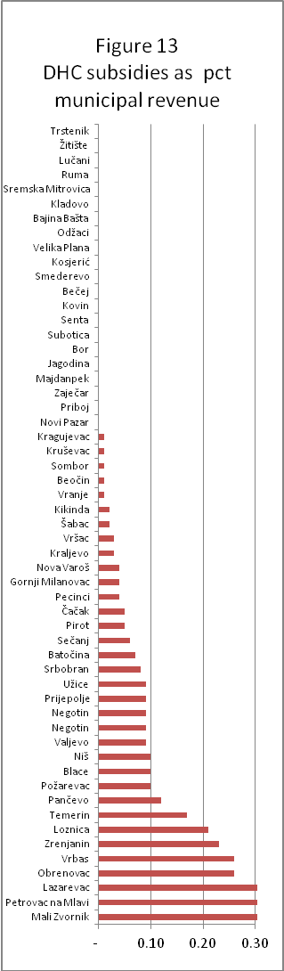
- But profit and loss data do not accurately indicate the financial burden that district heating companies impose on their municipal owners. There are several reasons for this. First, revenues reported by the district heating companies include municipal subsidies. According to the study by the Ministry of Regional Development and Local Government (MRDLG) study, 21 of the surveyed 56 companies received some form of subsidy in 2010. The level of subsidies ranged from one percent of company revenues in Krusevac to 67 percent of company revenue in Obrenovac.

- These explicit subsidies to district heating companies rarely constitute a significant drain on overall municipal budgets, however. As shown in Figure 13, with the exception of three outliers (Mali Zvornik, Petrovac ni Mlavi, and Lazarevac) municipal subsidies to district heating companies did not exceed 0.3 percent of municipal revenues in any municipality covered in the MRDLG study. The average was 0.07 percent. Explicit subsidies from the Belgrade city budget to its district heating company are also fairly modest. According to the 2011 budget execution report, the city provided no operating subsidies to the district heating company and spent only RSD 400 million on capital transfers, equivalent to 0.6 percent of current revenues.

- The true financial burden imposed by district heating companies instead takes other forms. The first is the cost of the capital investments that must be financed directly from municipal budgets. (As noted earlier, most of the costs of rehabilitating or replacing heating production and distribution facilities are borne directly by the municipal budget.) Since the early 1990’s, the largest cities (Belgrade, Novi Sad, and Nis) have made major investments in their district heating systems, installing more efficient boilers and repairing or replacing pipelines in order to reduce heat losses. According to the MRDLG study, further investment is needed. Under current circumstances, these costs would have to be paid from municipal budgets, rather than through heating tariffs.

- The companies also impose financial burdens on their creditors, in the form of arrears. These are largely owed to fuel suppliers. According to the MRDLG study, the arrears of district heating companies to energy suppliers totaled RSD 22,6 billion in 2010 (0.8 percent of GDP): RSD 18,06 billion for natural gas, RSD 3,15 billion for heating oil from the Commodity Reserves, RSD 472,5 million for heating oil from the free market, RSD 887 million for coal, and RSD 37 million for light oil.
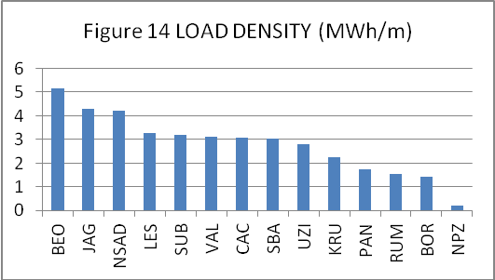
- Why do financial outcomes vary among companies? In operational terms, variations in financial results partly reflect variations in the characteristics of individual systems. One such factor is the density of the system; the number of customers per kilometer of network, or as more conventionally measured, the heat load density (defined as the amount of heat supplied per meter of network). Low density systems are more costly to operate than high density systems. Figure 14 illustrates variations in load density among 14 sample companies, including those of Belgrade and Novi Sad. (See Annex 2 for the full names of each jurisdiction.) As shown, load densities are considerably higher in Belgrade and Novi Sad than in companies serving smaller jurisdictions.

- A second factor is the number of hours per year that the systems operate at full capacity. Because capital costs are fixed, systems that operate at full capacity are less costly, per unit of heat produced, than those that operate only intermittently. Due to a history of overbuilding, capacity utilization is low throughout Serbia. Other factors are also at work. Unlike Western European systems that supply hot water year around, Serbian district heating companies operate only during the heating season. And even during the heating season, heat is only provided 16 hours per day, as opposed to 24. (Since these latter policies are uniform, they do more to explain why heating costs are higher in Serbia than in Western Europe; rather than why they are higher in one Serbian company than another.) As shown in Figure 16, capacity utilization is relatively uniform among the 14 companies surveyed.

- A third factor is the type of fuel used. Fuel types vary by price and energy output. Although most companies (including Belgrade and Novi Sad) rely on natural gas, some companies (such as Bor) rely on coal. While this does result in lower fuel costs per MWh of heat produced (see Figure 16), switching to coal is not a viable policy option, due to environmental concerns.
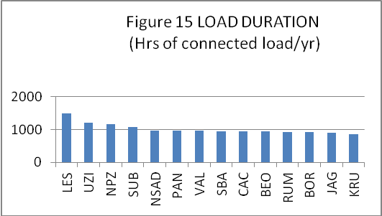
- Is labor policy a factor? To a small degree it is. Labor represents about 15 percent of total production costs. As shown in Figure 17, there are considerable variations in labor costs, per unit of heat produced, among companies. These range from RSD 400 per MWh in Novi Sad to RSD 1300/MWh in Krusevac.

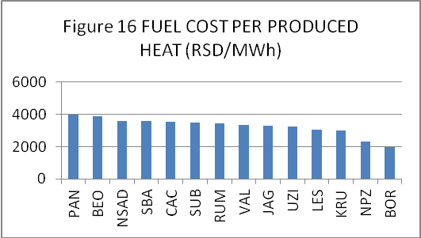
- Variations in labor costs, in turn, reflect both variations in staffing levels and variations in average salaries. It is often said that Serbian district heating companies are overstaffed. Compared to western European countries, they are. Modern district heating companies in western Europe typically generate about 10 GWh/per staff. In Finland this number is even higher: 20 GWh/staff. Countries in transition typically generate 4 GWh/staff. In Serbia, the number is typically about 1 GWh/staff. The exemption is Novi Sad with approximately 3.5 GWh/staff. As shown in Figure 18, staff productivity in the other companies surveyed falls far short of that figure.

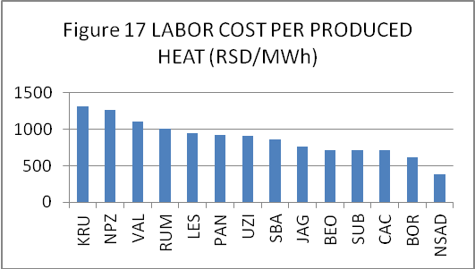
- And salaries? Average salaries do not vary much among companies, although they tend to be higher in larger cities. As shown in Figure 19, salary levels are highest in Novi Sad, Belgrade and Subotica. In Novi Sad, relatively high salary levels are more than offset by high levels of staff productivity. As a result, Novi Sad’s district heating company has the smallest wage bill per unit of heat produced.

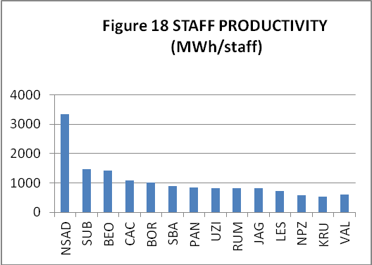
- Tariff policies do an inadequate job of financing the operating costs of district heating companies and impose an excessive financial burden on non-residential consumers. At present, tariffs are imposed in two ways: either on the basis of actual consumption or on the basis of estimated consumption, using floor area as an indicator. In Belgrade for example, most non-residential customers are charged on the basis of metered consumption. But residential customers are charged on the basis of floor area. Novi Sad, which is in the process of metering residential customers, has two tariffs for residential customers, one for metered consumers and one for those without meters. At present, only Subotica has comprehensive residential metering.

- Each municipality sets its own tariff levels. Methodologically, tariff calculations are based on a cost-of-service approach. Cost estimates are derived from one-year business plans, Expected levels of heat production, final consumption and losses are based on standard values and results from the previous heating season. The proposed base line tariff is calculated by dividing total costs by heated area (in the case of unmetered customers) resulting in a tariff in terms of RSD/m².

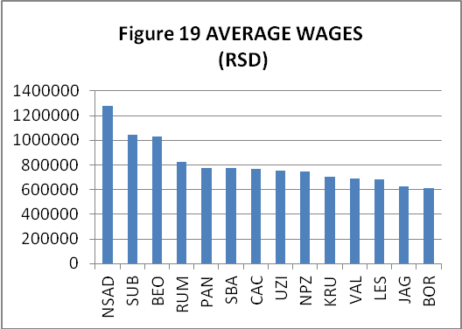
- Actual tariffs must be approved by municipal council. In general municipal councils are reluctant to approve tariff increases and often do so long after cost estimates have become outdated. As a result, revenues from heat sales tend to fall short of operating costs. Figure 20 shows heating revenues as a percent of heating costs for the 14 sample companies. As shown, heating revenues exceed heating costs only in Novi Sad and Sabac. (The company in Valjevo breaks even.) In Belgrade, tariff revenues cover only 75 percent of costs, according to this data source. In Bor, they cover only half.

- Municipal councils also have a pronounced tendency to shift the costs of district heating off of residential consumers and onto industrial and commercial consumers. Tariffs for commercial enterprises are typically double the tariffs for residential consumers. (Tariffs for government buildings such as hospitals and schools are typically somewhere in between.) As a result, district heating companies typically lose money on residential service and make it up (at least in part) by overcharging industrial and commercial customers. This strategy is increasingly unsustainable. Eventually, large industrial and commercial will choose to provide their own heating, rather than serving as cash cows for residential consumers.
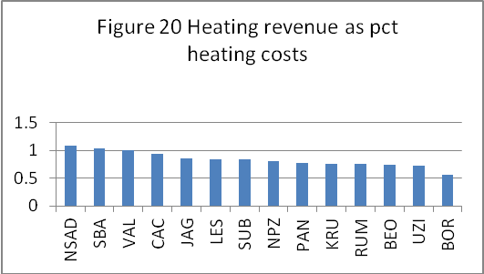
- What can be done? As in the case of water, there is a case for raising tariffs, particularly for residential customers. Consumers of district heating should make a larger contribution to the capital costs of supplying the service, rather than relying on municipal budgets. And the recurrent costs of the district heating should be borne by consumes rather than by creditors. Would raising district heating tariffs impose a major burden on the poor? Only in rare cases. Few poor people live in buildings served by district heating. Most of Serbia’s poor live in rural areas or in urban buildings without district heating. According to HBS 2010 data, only four percent of district heating customers are in the bottom consumption quintile and only one percent fall below the national poverty line. For these households, the financial burden of higher district heating tariffs could be addressed through targeted subsidies.
- But raising tariffs alone would merely shift the burden of inefficiencies onto consumers. What else can be done? The wide variation in financial performance among companies (and the relative success of Novi Sad) suggests that there are ample opportunities for efficiency gains, particularly among the poorest-performing companies. Some are technical. Companies could for example, introduce comprehensive metering for both residential and non-residential customers. By confronting individual consumers with the costs of the heating they consume, this is likely to reduce demand—and therefore the recurrent costs of heat production and distribution. As a first step, the companies could introduce mandatory metering for individual buildings. Costs could then be allocated among individual units on the basis of heated area or – better – by heat cost allocators (which are widespread in EU).
- In technical terms, there is also a case for right-sizing distribution networks in order to improve load densities—cutting off low density areas where district heating is not cost effective. There is also a case for rightsizing production capacity to improve capacity utilization. (Whether it would make sense to provide hot water during the summer in order to improve capacity utilization remains to be seen.) Improved leak detection and monitoring of illegal connections can also reduce technical and administrative losses. Is there a case for massive layoffs? Overall, there is evidence to support the claims of overstaffing. The vast gap in staff productivity between Novi Sad and the other surveyed companies suggests that most companies could get by with far fewer employees. But the cost savings will not be large, as the wage bill is not a large proportion of operating costs.

- From a management and governance standpoint, there may also be a case for imposing minimum professional qualifications for board members and managing directors (as in the case of the water sector and for the same reasons.) To strengthen fiscal discipline within the water companies, the companies’ creditors should also crack down on overdue payments. This may be politically difficult—Serbia-Gas would certainly find it awkward to shut off natural gas supplies to Belgrade in the middle of winter in order to force the payment of arrears—but less politically-charged remedies should be explored.

Public transit

- Municipal public transit services in Serbia are provided through a wide variety of arrangements. The largest municipalities own their own public transport companies. Municipalities (including the largest ones) also contract with private operators to provide service on specific lines. Even municipalities as small as Aleksinac (town population: 16,420) contract with a private operator to provide commuter service to nearby Nis.

- By far the largest and most expensive urban transport system in Serbia is that of Belgrade. The Belgrade system consists 1,717 km of regular bus routes, 122 km of tram lines, 56 km of trolleybus lines and 49 km of minibus routes, along with commuter rail lines operated by Serbia Railways. On an average working day, Belgrade’s system transports about two million passengers.

- The largest provider of public transport is Gradsko saobraćajno preduzeće (GSP) Beograd, a city-owned company that operates trams, trolleybuses, and buses. GSP is organized as municipal enterprise and operates under a service agreement with the city’s Public Transport Authority (PTA). Under this agreement, GSP Beograd has a monopoly on tram and trolleybus routes, as well as on certain urban bus routes. On remaining bus routes, it operates in conjunction with private operators and the bus company, SP Lasta, which is 62 percent owned by the Government.

- Private operators and Lasta provide service on specified lines under contract with the city. The private operators include two consortia--Beobus and the Business Association of Private Transport Operators (PUPA) along with six independent companies. Through the PTA, the city awards contracts to the operators through a competitive bidding process (which GSP Beograd does not participate in). At the last open tender in 2005, the contracts were signed for seven years. These contracts were later extended for another three years, rendering them valid until 2015. In addition to tram, trolley and bus services, commuter rail service is provided by the Government-owned Serbia railways, through its subsidiaries, BeoVoz and BG:Voz. While the city of Belgrade financed the renovation of rolling stock for the recently created BG:Voz lines, these services are otherwise financed entirely by Serbia railways, which in turn is subsidized by the central government.

- Expenditures on public transport make a significant claim on the city’s budget. This takes a variety of forms. The first consists of operating subsidies to GSP Beograd. GSP covers less than half its operating costs from tariff revenues. In 2011, tariff revenue covered only 45 percent of direct operating costs and 37 percent of total costs—only a slight improvement over the level of a decade earlier. This is a lower level of tariff coverage than in other ex-socialist countries. Polish, Latvian and Estonian cities reached 70-80 percent cost recovery levels (relative to total costs) in the early 1990s. Budapest Transport Company hovers around 50 percent, but with a large metro and suburban train networks and major investment in service quality. Of the 14 Russian cities that have participated in World Bank projects since 1995 (and which resemble Belgrade in size and modal characteristics) all have reached above 70 percent.

- As a result, the city is required to spend considerable amounts on operating subsidies to the company. As shown in Table 6, operating subsidies to GSP Beograd totaled USD 59 million in 2011, or about ten percent of the city’s total current expenditures. And even that was not enough. Despite the subsidies, GSP Beograd reported losses totaling US$ 22 million (RSD1,553 million) in 2011. This is a persistent problem: the cost recovery ratio in the previous three years has fluctuated between 77 to 88 percent. According to the State Audit Institution, GSP Beograd has arrears of about €13 million (RSD 1,313 million) solely in the form of liabilities to social insurance funds (pensions and health) and to the tax administration. Discussions with GSP Beograd suggested that they expect these arrears to be eventually paid from the municipal budget. In addition to its subsidies to GSP Belgrade, the City also spends a considerable amount on operating subsidies to private operators. As shown in Table 6, these totaled nearly USD 50 million (RSD 350 million) in 2011

- The city also spends a considerable amount on capital investments. As shown in Table 6, explicit capital subsidies to GSP Beograd totaled USD 6 million (RSD 424 million) in 2011. Major new capital investments are in the works. Since 2011, new trams have been purchased. Thirty of them were expected to be in operation by the end of 2012. The city is also planning to expand its bus fleet. In 2012, EBRD approved a loan of Euro 65 million to GSP Beograd to finance the purchase of 400 buses. The loan will be guaranteed by the City. On top of this, the city has ambitious plans to build a metro. The total cost of the three-line, 25 km system is estimated at € 2 billion. The first phase alone—a section of Line 1--is estimated to cost between €540-703 million. Tariff revenues will make no contribution to these costs.
Table 6 Expenditures on Transport in the City of Belgrade (US millions)
 | 2008 | 2009 | 2010 | 2011
Public Transport Authority (PTA) expenditures | 181.3 | 108 | 116.3 | 123.2
Subsidies to GSP Beograd | 93.9 | 56.3 | 52.9 | 65.0
Operating subsidy | 70 | 54.6 | 48.4 | 59.0
Capital subsidy | 24 | 1.6 | 4.5 | 5.7
Subsidies to SP Lasta | 19.1 | 0 | 0 | 0
Operating subsidy | 19.1 | 0 | 0 | 0
Subsidies to Private operators | 37 | 39.9 | 44.8 | 48.6
Expenditures / Investments in railways | N/A | 4.5 | 9.6 | 0
Domestic loans / credits | 0 | 0 | 4 | 0
Own incomes | 26.2 | 0 | 0 | 0
Surplus from previous years | 0 | 7.6 | 4 | 2
Total City of Belgrade expenditure | 1056.1 | 973.6 | 956.9 | 999.9
% of City expenditures on transport | 0.28 | 0.26 | 0.25 | 0.22
Received from central government | 111.5 | 41.1 | 43.5 | 40.1
- In principle, higher levels of tariff coverage would reduce the need for subsidies. So why is tariff coverage so low? Part of the reason is that tariffs are relatively low by European standards. As shown in Table 7, the price of a full fare daily ticket in Belgrade (USD 0.83-1.68) is higher than in Bucharest, but considerably lower than in Zagreb or Budapest, let alone Madrid and Paris. The problem is also that there are too many exemptions. As shown in Table 7, anyone under high school age or over the age of 65 rides for free, along with members of the armed service and pregnant women. Other European cities also offer discounts for particular categories of riders, but they tend to be less generous. Some are means-tested. In Paris, for example, the discount for pensioners is subject to a means test, which determines whether they travel at a 50 percent discount or for free. In Zagreb the discounted public transport ticket is obtained only on request and only if the applicant has a low income or is on welfare.

- A second problem is fare evasion. Until recently, passengers were expected to purchase paper tickets at kiosks or use monthly passes. These were not checked upon entry, however. Instead they were subject to random checks by roving inspectors, which were routinely evaded. In February 2012, the city introduced a new electronic ticketing system, BusPlus, on lines operated by GSP-Beograd, Lasta, Serbian Railways and the private operators. In principle, passengers are required to present the card on entry, ‘validating’ it on an electronic scanner posted at the entrance to each vehicle. Compliance is checked by 500 control officers. Data from the first three quarters of 2012, suggest that this measure has succeeded in increasing tariff revenue somewhat. On an annualized basis, revenue on urban lines have increased by about ten percent (see Table 9). But there is anecdotal evidence of continued evasion—estimated to be still as high as 30 percent. This is in part because incentives for paying continue to be weak. Although the financial penalty for failing to pay is significant, vehicle operators do not refuse entry to passengers who have not validated their tickets. For their part, inspectors have little enforcement power. They can demand to see tickets but passengers can refuse to comply. Even if a customer admits to evasion, the resulting fine is rarely enforced. Recently, the situation has gotten worse. In September, the mayor of Belgrade announced that passengers with monthly prepaid subscriptions no longer have to validate their tickets. (This was in response to complaints that the validation process was delaying boarding.) As a result, evasion is likely to continue at high levels.
Table 7– Comparison of Fare Levels in Selected European Cities (US dollars)

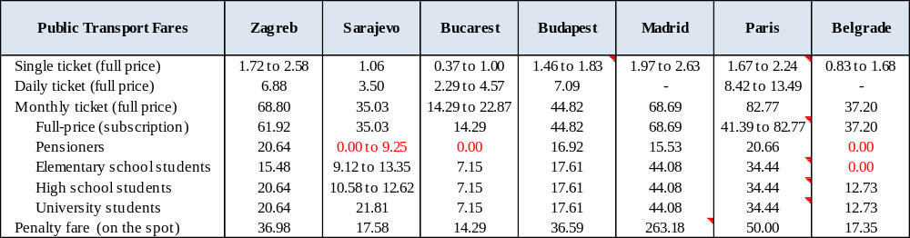

Table 8 – Public Transport Discount by Category

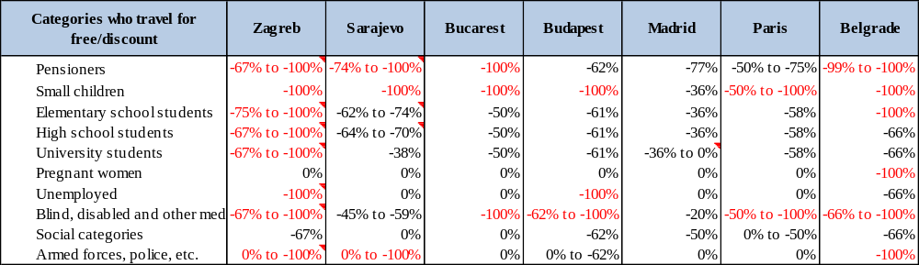

- A more fundamental cause of high tariff evasion is the fact that operators have no incentive enforce payment. Under their current contracts, operators (including GSP-Belgrade) are paid on basis of gross operating costs. Tariff revenues are not retained by the operators; instead they are paid into the PTA. As a result, operators have no incentive to ensure that fares are paid.
Table 9 Trends in Fare Revenues (USD millions)
Year | Urban (ITS1) |  | Suburban (ITS2) |  | Total
Year | Private operators + SP Lasta-urban | GSP Beograd | Private operators | SP Lasta | Total
2009 | 21.1 | 61.7 | 0.472 | 15.4 | 98.7
2010 | 20.9 | 59.4 | 0.365 | 13.4 | 94.1
2011 | 23.9 | 66.2 | 0.364 | 14.4 | 105
2012 (q1-q3) | 19.5 | 54.7 | 0.722 | 11.4 | 86
2012 annualized | 26.0 | 72.9 | 1.0 | 15.2 | 114.7
Pct increase 2011-2012 (annualized) | 9% | 10% | 164% | 6% | 9%

- In principle, tariff revenue could be increased by addressing each of these problems. Full fare tariffs could be increased. Categorical exemptions could be reduced. In particular, exemptions aimed at reducing costs for low income passengers could be better targeted. Rather than exempting entire categories of passengers, such as pensioners, exemptions could be means tested, as they are in Paris or Zagreb. Several measures could be taken to reduce evasion. First, the mayor could reinstate the requirement that all passengers validate their BusPlus passes. Second, individual vehicle operators could enforce this requirement by refusing entry to passengers who refuse to do so. Incentives for tariff collection could be strengthened by changing the terms on which contract terms are awarded to individual operators. Rather than awarding contracts on the basis of gross costs, contracts could be awarded on the basis of net costs.

- But (as in the case of water supply) focusing solely on tariff increases would merely shift the costs of existing system inefficiencies onto passengers. Evidence of such inefficiencies exists. First, labor costs appear to be excessive, particularly in GSP-Beograd. In 2011, wages and salaries constituted nearly 50 percent of GSP Beograd’s expenditures. In contrast. Lasta had a wage bill equal to 28 percent of total expenditures. Anecdotal evidence suggests that this is not because the number of staff employed by GSP-Beograd is excessive, but rather because existing union contracts call for a relatively short working day, requiring the company to pay excessive amounts of overtime. Second, the network is overextended. On some lines there are there are too few passengers to justify the current level of service. Cutting the frequency of service could save money. The PTA intends to address the former problem through an EBRD supported retrenchment plan (as noted earlier). It intends to address the latter problem through a comprehensive review of the existing transit network. The review will assess the length, capacity and frequency of service on all public supported lines, with the aim of reducing overlaps and better matching supply to demand. This should be a priority.

- The city could also reduce the need for subsidies by awarding public transit contracts on a competitive basis. As noted above, operators (including GSP-Belgrade) are paid on basis of gross operating costs. The amount paid to each operator is determined on the basis of a formula, , in which the number of seat kilometers served by each bus is multiplied by a standard amount, expressed in RSD. The number of seat kilometers for a given bus is calculated by multiplying (1) the number of scheduled bus departures by (2) the number of seats on the bus and (3) the length of the bus route. In the cases of Lasta and private bus operators, an additional adjustment is made to reflect the age of the bus.) The standard amount is fixed at the time the contract is awarded, and is intended to cover operating costs, drivers' wages, amortization, and a small return to investment. What is critical, from an operator's standpoint, is the standard amount that is paid per seat kilometer. If an operator can provide the contracted service for less than this amount, the operator makes a profit. If not, it makes a loss. As a result, the operator has an incentive to operate efficiently. But the city does not benefit from any efficiency gains on the part of the operator: the amount it has to pay to the operator is fixed at the time the contract is awarded. To address this problem, contracts could be awarded on a competitive basis when they next come up for tender. Even if payment continued to be made on the basis of gross (rather than net) costs, operators could compete on the basis of price--i.e., on the basis of the amount per seat-km that they are willing to accept. If the PTA chooses to award contracts on the basis of net costs, contracts could similarly be awarded on the basis of the amount per seat kilometer the operator is willing to accept, with the amount, in this case, expressed in terms of net costs. This would have the additional benefit of encouraging tariff enforcement.

- Unfortunately, all these efforts to reduce subsidies may be offset by the city’s ambitious metro project. The new, high-capacity system proposed for the city has not been subject to sufficient economic and financial analyses. In particular, lower cost alternatives have not been seriously considered. This decision should be re-evaluated before major funds are committed.

Other municipal enterprises

- Municipalities are the founders of a large number of enterprises in other sectors, some of which are quite large. The sixth largest municipal enterprise in Serbia is the Belgrade solid waste management company, with revenues of RSD 4.14 billion in 2010 and profits of RSD 243 million (according to the company’s official financial report). Another large company is the Belgrade housing maintenance company. This is a holdover from the era of socialized multi-family housing. With privatization, individual housing units have been sold to their occupants, but the Belgrade housing maintenance company continues to provide routine maintenance of building facades and roofs, common areas, and elevators and well as monthly cleaning services in ten of Belgrade’s 17 city-municipalities. According to its 2012 revised budget, the company has revenues and expenditures of RSD 2.4 billion. It is largely financed from maintenance and cleaning fees. The amount of the maintenance fee is based on the floor area of each unit, regardless of the building’s location. (The fee is higher for buildings with elevators than for buildings without them.) The cleaning fee is a fixed amount per apartment. The company’s managing board sets the fees, subject to the approval of the city council. The maintenance fee covers only routine maintenance. Major repairs (such as rehabilitation of façades or the replacement of elevators) require a separate agreement with the association of owners, with a separate payment. (If elevator is beyond repair, the company will shut it down (for safety reasons) but will not replace it unless owner association agrees to pay.) Purchasers of units in new apartment buildings do not have to sign contracts with the maintenance company, although they are legally required to ensure that common areas are maintained.

Fundamental management reforms

- Are fundamental management reforms required? Critics have charged that improvements in the operational efficiency of municipal enterprises are not likely to occur without fundamental changes in the governance structure of the utilities. The Government’s Strategy for Restructuring Public Utilities claims that it is poor management that ultimately accounts for the poor performance of municipal enterprises. It attributes these weaknesses, in part, to the politicization of management—the tendency of managers to be appointed for political reasons (rather than competence) and to change with every change in local political leadership. As a result, it is claimed, even competent managers focus on short term results. These concerns are echoed in the program document for the World Bank-supported PEDPL, which states, ‘corporate governance of PUCs is a major challenge due to political interference. Similar to other groups of public enterprises, there is a politically driven process for management and board selection that produces suboptimal outcomes in terms of quality of managerial skills and independence of decision making. This poor governance model contributes to the poor performance of municipal public utilities.’

- The previous Government worked on a strategy for the reform of local utility companies (the latest available draft is from June 2011) but failed to officially approve it or implement it. The draft Government Strategy for Restructuring Public Utility Companies lays out some solutions. The first is to change the criteria for selecting members of public utility boards. As proposed by the draft Strategy, at least 50 percent of the managing board should be people with relevant professional experience and not affiliated with political parties. Their terms should be staggered so they do not all change with each change in municipal administration. By the same token, the managing directors of public utility companies should be required to have at least five years relevant work experience. Like board members, they should be required to disassociate themselves from political affiliations. The Strategy also advocates a new instrument of accountability: a ‘service agreement’ between the municipality and the public utility which sets out operational and financial targets to be achieved over a specific time frame and defines the level of financial support to be provided by the municipal budget during that period. The service agreement would also require municipal utilities to prepare business plans, setting out projections of revenues and expenditures and projected tariff levels. It should be noted that the existing law on public enterprises already requires utilities to have business plans and stipulates that any failure to prepare annual business plans in accordance with the law is punishable by a suspension of budget transfers from central government. These provisions have not been noticeably effective.

- The Strategy also proposes several changes in the organization and legal status of municipal utilities. According to the Strategy, responsibility for capital investment and operations should be consolidated in each company (as opposed to the current arrangement in which capital investment is a municipal responsibility and companies are merely operators). By the same token, ownership of water supply assets should be transferred from the state to the municipalities, allowing each municipality to then transfer the assets to the company or enter into contracts with the company governing the lease or use of the assets. The Strategy does not provide much justification for these recommendations, however, and neither would appear to be a sine qua non of reform. France, for example, has a long and successful history of employing private companies to operate water utilities, while leaving communes responsible for building and owning water assets.

- The Strategy also recommends transforming utilities into companies regulated by the law on commercial entities. This would allow the utilities to become joint stock companies, which would in turn facilitate partial private ownership and facilitate regional consolidation (i.e., the consolidation of separate municipal water companies into a single company serving several different jurisdictions). Again, neither appears to be a vital component of reform. As the Strategy itself concedes, the prospects for persuading private investors to take equity positions in Serbian water utilities are poor, at least in the short term. And the benefits of consolidating separate water utilities into a single organization are limited. Serbian municipalities are large, in territorial terms. A company owned by a single municipality can already serve several different towns within the municipal boundaries. By the same token, the savings to be achieved through consolidations are, in most cases, likely to be small. Unless they rely on joint production facilities, water systems operate in physical isolation: one system serves one town. Any economies of scale to be derived from consolidation would involve only from savings in administration or the purchase of supplies in bulk. According to the EBRD, the EU will nevertheless insist on the consolidation of water companies as a condition of EU funding.

Controlling Municipal Borrowing

Contractual Debt

- In addition to the burden that local governments currently impose on the central government budget, the Government faces the prospect of a future explosion of municipal debt—and possible demands for bailouts.

- Under the public debt law, municipalities are permitted to borrow to finance capital investment. They may borrow in domestic and foreign capital markets, in domestic or foreign currency, and in the form of loans or bonds, subject to certain ceilings (discussed below). From a macro perspective, the current stock of municipal debt is not large. The stock of local government debt as of end-October 2012 was equal to only two percent of GDP. With the exception of Belgrade, the current stock of debt also does not appear to be particularly large in terms of municipalities’ ability to pay. Excluding Belgrade, the stock of municipal debt was equal to only 17 percent of current municipal revenues in 2011. The stock has, nevertheless, been growing rapidly. As shown in Figure 21, the total stock of municipal debt more than doubled in Euro terms between end-2009 and October 2012.

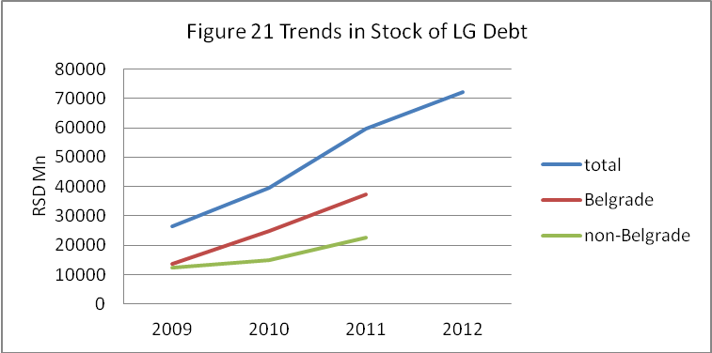
- Slightly more than half of total municipal debt is owed to IFIs, which offer terms that are more favorable than those of commercial banks. The main IFI creditors are the EBRD and EIB. But debt to domestic creditors has been growing. Since 2001, the stock of debt to local commercial banks has increased ten-fold (in Euro-terms). (See Figure 22). In addition, municipalities are now beginning to enter the bond market. So far only two local governments have issued bonds: Novi Sad and Pancevo. But seven more local governments including Belgrade, are considering issuing bonds in 2013, and have obtained technical assistance from bilateral donors to assist them in doing so.

- Given relatively low level of aggregate municipal debt at present, is there cause for concern? There is, for several reasons. The first is the particular case of Belgrade. Belgrade’s stock of debt is large and growing. As of end-2011, the stock of debt owed directly by the city totaled RSD 37.3 billion. The was equivalent to nearly 60 percent of the city’s current revenue in 2011. The burden of servicing that debt is already significant. According to budget execution data for 2011, debt service totaled RSD 3,825 million, or six percent of total current revenues. Most of this debt was contracted in the previous four years for major infrastructure projects, including the new bridge over Sava river, tram lines and reconstruction of utility companies’ facilities. Most of it was financed by IFIs. As grace periods expire, the debt service burden is likely to increase. Even if the city took on no new debt, the burden of debt service, without grace periods, would be eight percent of current revenues.
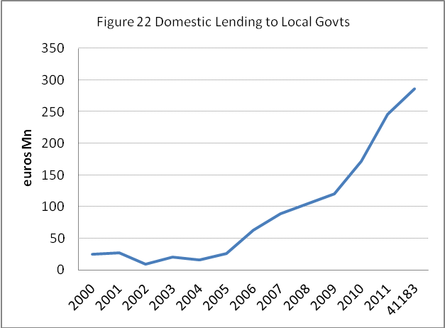
- A second reason to worry is that other large municipalities may be following Belgrade’s example. The debt:revenue ratio in Kragujevac is already 33 percent. In Nis, the stock of debt increased from RSD 41.8 million at end of 2010 to RSD 1,197 million at end of 2011, yielding a debt:revenue ratio (as of the end of 2011) of 22 percent.

- The risks of municipal indebtedness are compounded by the terms on which it is contracted. The vast majority of municipal debt is denominated in foreign currencies. As shown in Table 10, nearly 80 percent of municipal debt was contracted in foreign currencies as of end-October 2012—most of it in Euros. In addition, most loans (73 percent) are contracted at variable interest rates. Most of these loans (79 percent of variable-interest rate loans) have interest rates tied to Euribor. As a result, any decline in the dinar against the Euro could provoke a sharp increase in the stock of municipal debt, in dinar terms. And any increase in Euribor rates could increase debt service obligations still further.

- What is to be done? One obvious first step would be to tighten regulations on municipal borrowing. In some respects, current central government regulations on local borrowing are already fairly restrictive. Short term debt must be repaid before the end of the calendar year. In the case of debt with a maturity of a year or longer, ceilings are imposed on both the stock of debt and the level of debt service. The total stock of outstanding debt may not exceed 50 percent of current revenues in the preceding year. Total debt service (principal and interest) in the current year may not exceed 15 percent of current revenues in the previous year. But the ceiling on the debt stock is waived if two conditions are met. First the proposed new debt must have a maturity of five years or more, after grace periods. Second, the local government’s current surplus, multiplied by two-thirds, must be greater than 15 percent of its current revenues. These exceptions were reportedly inserted into the law for the benefit of the City of Belgrade, which had exceeded the ceilings provided in the original legislation. They are potentially dangerous. In effect, a municipality can evade the normal debt ceilings, for loans with maturities of five or more years, if it has even a temporary bulge in revenues. Under these conditions, the municipality would be subject to no ceiling at all.

- It is clear that the exception in the debt ceiling should be closed. Should the remaining ceilings be further tightened? By international standards, the 50 percent ceiling on the debt:revenue ratio is fairly conservative. It is, however, consistent with the 15 percent ceiling on debt service. And in an environment of frequently changing exchange rates (and debts denominated in foreign currency), variable interest rates, and fluctuating municipal revenues (over which municipalities have little control) this degree of conservatism is desirable.
Table 10 Stock of Municipal Debt, by Currency RSD Mn
 | EO 2009 | EO 2010 | EO 2011 | EO Oct 2012
Debt contracted in EUR | 24,547 | 32,388 | 49,567 | 55,582
Debt contracted in RSD | 1,314 | 6,790 | 9,771 | 16,243
Debt contracted in CHF | 447 | 511 | 452 | 404
Stock of debt | 26,309 | 39,689 | 59,790 | 72,229
pct in RSD | 5% | 17% | 16% | 22%
Voivodina is included in these figures. Its debt is mainly denominated in Dinars at stood at RSD 5.6 billion at the end of October

- Ex ante regulations on local government borrowing do not, of course, prevent ex post defaults. Municipalities may default on loans even if they have the wherewithal to pay them. Under these circumstances, it is important that the central government possess the tools to force municipalities to honor their obligations. Otherwise creditors are likely to demand relief from the central government itself. (The Government might be able to ignore such demands in the case of a small and remote municipality. But it is unlikely that the Government would be able to stand aside while Belgrade defaulted on a large obligation—even one without a government guarantee.) The current law provides that, if a municipality fails to honor its debt service obligations to a creditor, the central government may pay those obligations on the municipality’s behalf and deduct the amount from the shared taxes and intergovernmental transfers that would otherwise be transferred to the municipality. This is a useful provision. But it is important that such central government intervention remain discretionary. Lenders should not come to expect the central government to make good on any loan made to a local government. By the same token, when the Government does decide to pay debt service on behalf of a municipality, it should consistently enforce the debt service recovery provisions in the law. Municipalities should not come to expect bailouts from the central government.

Municipal Arrears

- In addition to the growing stock of contractual debt, municipalities are accumulating a growing stock of arrears. This is a concern, first, because it is an indication of local governments’ inability or unwillingness to meet their obligations. But it could also pose a fiscal threat to the central government. If local authorities persist in running up arrears, the stock will accumulate until local governments have no prospect of paying it down. Then demands for central government bailouts will arise—demands that are already in evidence.

- The current extent of municipal arrears is difficult to determine. Comprehensive data on the current stock of municipal arrears does not exist. Most local governments in Serbia have no system for regularly recording and reporting overdue payments. The best available source is a survey undertaken by the Standing Conference of Town and Municipalities. The most recent survey reflects the situation as of end-April, 2010. As shown in Table 11, the stock of arrears reported by the survey totaled RSD 16.9 billion or 0.6 percent of GDP. But this is likely to be an underestimate. Several large municipalities, including Belgrade and Kragujevac—did not respond to the survey.

- The largest share of arrears are owed to private sector construction companies and other private suppliers of goods and services. As shown in Table 11, nearly 60 percent of arrears fall into this category, with arrears to construction companies predominating. Another 27 percent is owed to public utilities—principally the state natural gas company Srbijagas (15 percent of the total) , the electric power company (nine percent), and the since-privatized oil company (three percent). Municipal administrations themselves account for a relatively small proportion of total. As shown in Table 11, only 17 percent of total arrears are owed by municipal administrations. The majority is instead owed by the utility companies owned by the municipalities—nearly 70 percent of the total. Arrears to construction companies account for about half this total, with arrears to utility companies (particularly Serbiagas) accounting for much of the remainder.

Table 11 Outstanding Stock of Local Government Arrears, April 30, 2010 (RSD thousands)
 | To construction firms and other private providers | To State Public Company “Srbijagas” | To Electric Power Company (EPS) | To Oil Industry of Serbia (NIS) | Other (to employees, etc) | Total | pct of total
Municipal administrations | 2,079,206 | 14,216 | 208,711 | 10,849 | 522,294 | 2,835,277 | 17%
PUCs | 5,813,831 | 2,524,579 | 1,060,525 | 467,357 | 1,697,901 | 11,564,196 | 68%
Other organizations | 1,800,066 | 52,288 | 209,545 | 51,048 | 412,810 | 2,525,759 | 15%
Total | 9,693,103 | 2,591,083 | 1,478,781 | 529,254 | 2,633,005 | 16,925,232 | 100%
Percent of total | 57% | 15% | 9% | 3% | 16% | 100%
- Controlling arrears is more difficult than controlling contractual borrowing. Central government ex ante ceilings on municipal expenditure commitments would be impossible to administer: the volume of transactions is too large. The government is now trying a different approach. In December, Parliament approved legislation requiring all public sector debts to private businesses to be paid within 45 days of their due date. The law provides fines of between RSD 5,000 and RSD 150,000 for state officials and managers who fail to do so. This too may be over- ambitious. Guilt will be difficult to establish in an environment of fluctuating revenues and competing expenditure demands. In principle, an entire municipal council could be fined for failing to enact a supplementary budget funding the payment of arrears.

- In theory, arrears ought to be self limiting. It takes two parties to run up arrears—a local government and its creditors. While local governments may hope to delay paying their creditors as long as possible, in principle, creditors will cease supplying goods and services if payment is not eventually forthcoming. But this mechanism does not work so well in practice. In the case of public sector suppliers such as Srbijagas, political considerations may prevent a cut off in supplies. Private contractors, for their part, often simply inflate prices to compensate for expected delays in payment. (In Nis, it is reported that contractors are typically paid 180 days in arrears, but consider this the price of continuing to do business with the city.) What is critical is to avoid creating the expectation—on the part of both municipalities and creditors--that the central government will eventually provide a bailout. If this expectation is created, suppliers will continue to accept delayed payments, with the understanding that the central government will eventually make them whole.

- The Government now in the process of creating this expectation. In January 2013, the MOF announced a plan to refinance local government arrears to construction firms. Under the proposal, the Government will issue bonds to road building and other construction companies that carried out works prior to October 2012. The bonds will be amortized over 24 months following a one-year grace period. (They will be inflation-indexed and pay two percent interest.) To service the bonds, the Government will withhold the amounts due from the PIT and intergovernmental transfers of each municipality.

- It is conceivable that only legitimate claims for payment will be presented by the construction companies and that the Government will manage to retire the bonds (with interest) over the next three years by withholding the amount due from the local governments. But it is also conceivable that unscrupulous contractors will present illegitimate claims (in the hope of obtaining legitimate government bonds). Worse yet, it is conceivable that two or three years hence, with the fiscal crisis still not fully resolved, the Government will find itself politically unable to withhold the required debt service from the municipalities that have taken advantage of this program. Under such conditions, the Government will be under pressure to again refinance the arrears, setting a dangerous precedent for the future.

- For their part, individual municipalities can take measures to forestall arrears in the future by improving their systems of commitment control. (Commitment control is a part of the budget execution process in which spending commitments are checked against budget allocations before they are incurred.) But for commitment control to be effective, budgets must be realistic. In the Serbian context, realistic budgeting is difficult, given the frequent changes in the rules governing intergovernmental fiscal relations. In fact, much of the current stock of arrears dates from the period when the Government ceased to fully fund the block transfer. The Government can alleviate this problem by adopting a more stable structure of intergovernmental relations, as discussed in the final section of this report.

Summing Up

- This report is focused on the Government’s immediate concern: the deficit and the contribution that recent increases in municipal resources have made to it. Although the question ‘do local governments have too much money?’ cannot be answered definitively, one conclusion is clear. During the current fiscal crisis, both the central government and the local governments must cut back. Reductions in central government spending must be accompanied by reductions in local government spending. The only immediate question is how.

- The best approach would be the direct approach: the Government should roll back the recent increase in the municipal share of the PIT. An alternative would be to reduce the level of block transfers. Adjusting on the expenditure side—transferring new expenditure responsibilities from the central government to local governments—is not a promising solution. The difficulties of doing so are illustrated by the recent experience with decentralizing regional road maintenance.

- At the same time, municipalities could take actions that would reduce their need for central fiscal support. One way would be to increase the yield of locally-administered taxes and fees. Yields of the property tax, for example, could be increased by valuing industrial and commercial property at market prices. Another approach would be to reduce the fiscal burden posed by public utilities. Tariffs on water supply and district heating could be increased. At the same time, costs could be reduced by metering individual consumption and rationalizing networks. In Belgrade’s public transport system, similarly, revenues could be increased by cutting tariffs exemptions, improving collection enforcement, and reducing service on underused lines. In a broader sense, there may also be opportunities to improve the efficiency of services financed directly from the municipal budget, such as preschool education and road maintenance. None of these measures would, of course, directly reduce the fiscal burden that municipalities now impose on the central government. But they would permit the central government to scale back its fiscal support to municipalities without necessarily forcing a decline in the quality of municipal services.

- At this stage, worse may be yet to come. Municipal claims on the central government could grow, in the form of demands for debt bailouts. Belgrade is now exploiting the gap in the debt ceiling to borrowing imprudently. Other municipalities may follow suit. At the same time, the Government’s current initiative to refinance municipal arrears may inadvertently encourage suppliers and contractors to extend even more credit to municipalities in the future. To forestall this outcome, the Government should close the gap in the debt ceiling, refrain from refinancing arrears, and aggressively recover debt service from municipalities in default on their existing obligations.

- While the deficit is the immediate focus of this report, broader problems in intergovernmental relations also need to be addressed. The fiscal relationship between the central government and the municipalities is becoming increasingly dysfunctional. The system established in 2007 had much to recommend it. The system of PIT sharing ensured that municipalities had an instrument with which to tax themselves, while the equalization element in the transfer system ensured that even municipalities with weak PIT tax bases had at least a minimum level of revenue. The rule for determining the overall level of transfers was objective and transparent as were the rules for determining their distribution among individual jurisdictions. Since then, the Government has arbitrarily reduced the level of transfers and then increased the municipal share of the PIT, mismanaged the transfer of road maintenance onto municipalities and opened a gaping hole in the debt ceiling. It is now planning to refinance municipal arrears, setting a dangerous precedent. There is a strong case for returning to a stable and transparent system of intergovernmental finance, backed by a hard budget constraint. It need not necessarily match the 2007 system. But it should provide local governments with a clear indication of the level of resources they can expect in future years and then force them to make do within that envelope.

- There is also considerable room for improvement in the internal management of municipalities. Targets include both staff functions (financial planning, personnel management, capital investment planning) and line functions (the delivery of specific services.) These issues will be addressed in the next phase of this work.

Annex 1 Case Studies

Belgrade

- The City of Belgrade is the heart of Serbian political and economic life. The city has a total population 1.7 million, of which 1.4 million live in the city proper, and is divided, for administrative purposes, into 17 so-called city municipalities. These are subordinate to the city administration and (with some exceptions) have few independent functions. The city administration itself consists of 14 secretariats, along with various agencies, institutes and municipal enterprises.

Revenues

- In 2011, Belgrade’s receipts, including net borrowing but excluding tariff revenue retained by municipal enterprises, totaled RSD 74.4 billion, or roughly €465 per capita. Current revenues account for 85 percent of this, with the remainder derived from borrowing.
- The largest single source of municipal revenue is the municipal share of the centrally-administered payroll tax. In 2011, it accounted for 42 percent of total current revenues. (See Table A1). This reflects, in part, the impact of the decentralization amendment, which increased Belgrade’s share of the PIT collected in its territory from 40 percent to 70 percent. This provision came into effect in October 2011. The full impact of the increase will be observed in 2012. The city’s 2012 budget foresees an increase in PIT revenues of 37 percent, bringing its share of total current revenues to 50 percent.
Table A1 Belgrade Sources of Revenue
(RSD mn)
 | 2011 | 2012
Current income | 62,786 | 72,737
PIT, transfer tax | 29,303 | 39,234
unearmarked transfer | 3,246 | -
other shared revenues | 1,506 | 1,424
property tax, land use fee | 12,658 | 14,435
utility taxes | 3,105 | 4,407
land development fee | 5,627 | 6,500
rents from mun property | 4,526 | 4,232
other | 2,815 | 2,505
Capital receipts | 14,281 | 11,734
foreign borrowing | 11,332 | 10,967
domestic borrowing | 2,885 | 682
other | 64 | 85
TOTAL | 77,067 | 84,471

- Belgrade’s second largest revenue source is the property tax and the related fee for the use of urban land. Together, these accounted for 20 percent of current revenues in 2011. The land development fee accounted for just under ten percent. (See schedule of land development fees, Table A2.) Revenues from the lease of city-owned land and office space are also a significant source of revenue, accounting for seven percent of current income in 2011. In 2011, Belgrade also received block transfers from the central government (under budget classification 733141) of about RSD 3.2 billion. Under the decentralization amendment, Belgrade’s share of block transfers will drop to zero. The City has budgeted nothing for this revenue item for 2012. Still, the city is a net gainer from the decentralization amendment. Its increase in PIT revenues is ten times its losses from the elimination of its equalization transfer. The City was also major borrower in 2011. Proceeds from borrowing totaled RSD 14.2 billion, increasing Belgrade’s total resource envelope by about 23 percent (i.e., receipts from borrowing divided by current income). Although part of this represents borrowing to finance the construction of the new Sava bridge, it is not necessarily a one-time anomaly. Belgrade’s gross proceeds from borrowing totaled RSD 11.5 billion in 2010 and are budgeted at RSD 11.6 billion in 2012.

Table A2 Belgrade Land Development Fee: RSD per Square Meter of Floor Area
 |  |  |  | Zone
type of structure | type of fee | green zone | deluxe zone | 1 | 2 | 3 | 4 | 5 | 6 | 7 | 8 | specific zone
housing | trunk infrastructure | 24.325 | 16.217 | 10.425 | 9.034 | 7.646 | 5.999 | 4.449 | 3.114 | 1.558 | 0.468 | 5.999
housing | primary and secondary network | 19.901 | 13.267 | 8.529 | 7.393 | 6.254 | 2.987 | 2.290 | 1.603 | 0.801 | 0.240 | 2.987
housing | total | 44.226 | 29.484 | 18.954 | 16.427 | 13.900 | 8.986 | 6.739 | 4.717 | 2.359 | 0.708 | 8.986
com-mercial | trunk infrastructure | 51.239 | 34.160 | 25.347 | 17.879 | 13.112 | 10.947 | 8.189 | 5.732 | 2.867 | 0.860 | 10.947
com-mercial | primary and secondary network | 19.901 | 13.267 | 8.529 | 7.393 | 6.254 | 2.987 | 2.290 | 1.603 | 0.801 | 0.240 | 2.987
com-mercial | total | 71.140 | 47.427 | 33.876 | 25.272 | 19.366 | 13.934 | 10.479 | 7.335 | 3.668 | 1.100 | 13.934
production facilities | trunk infrastructure | 51.239 |  | 25.347 | 17.879 | 13.112 | 8.874 | 6.355 | 4.449 | 2.225 | 0.668 | 8.874
production facilities | primary and secondary network | 19.901 |  | 8.529 | 7.393 | 6.254 | 2.987 | 2.290 | 1.603 | 0.801 | 0.240 | 2.987
production facilities | total | 71.140 |  | 33.876 | 25.272 | 19.366 | 11.861 | 8.645 | 6.052 | 3.026 | 0.908 | 11.861
other | trunk infrastructure | 24.325 |  | 7.603 | 5.266 | 4.794 | 4.992 | 2.436 | 1.705 | 0.853 | 0.256 | 4.992
other | primary and secondary network | 19.901 |  | 8.529 | 7.393 | 6.254 | 2.987 | 2.290 | 1.603 | 0.801 | 0.240 | 2.987
other | total | 44.226 |  | 15.592 | 12.659 | 11.048 | 7.979 | 4.726 | 3.308 | 1.654 | 0.496 | 7.979

Expenditures

- In functional and organizational terms, Belgrade’s devotes the largest share of its budget to infrastructure. (See Chart A1.) Responsibility for infrastructure is divided among several departments (secretariats, directorates and agencies) and various municipal enterprises that are subordinate to them. The largest department, in terms of spending, is the Belgrade Land Development Directorate (Direkcija za građevinsko zemljište i izgradnju Beograda JP). The Directorate is primarily responsible for preparing construction land for development. This may involve the demolition of existing buildings, site grading, and the extension of water supply, sewerage, and access road networks to the site. The agency is also responsible for the construction of the new Sava Bridge.
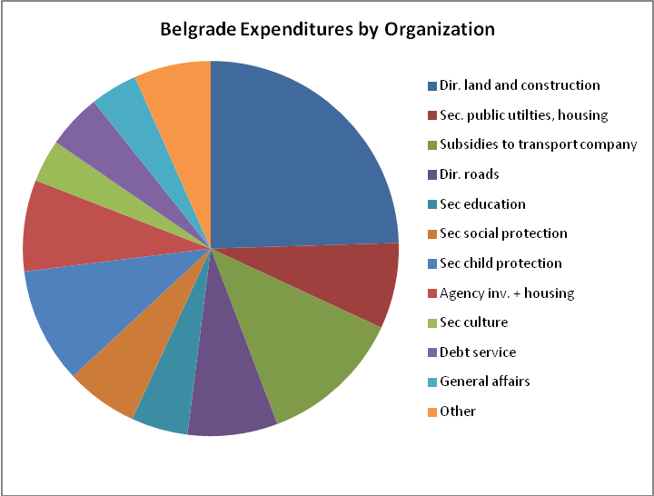
- A second major spender is the Secretariat for Utilities and Housing Services. The Secretariat oversees a wide range of municipal utility enterprises. These include: (1) the city water company (Beogradski vodovod i kanalizacija) which is responsible for operating (but not constructing) water supply, sewerage, and storm drainage systems throughout the city; (2) the city district heating company, (3) the city waste management company (Gradska čistoća) which provides solid waste collection and disposal in ten of the city municipalities, and (4) several smaller companies responsible for parks, street lighting, etc. The Secretariat also oversees the city housing maintenance company, JP Gradsko stambeno. Gradsko stambeno is responsible for maintaining the common areas of much of the multi-family housing mainly constructed during the socialist regime. This includes the repair of equipment (such as elevators) the maintenance of facades and rooftops, and the cleaning of lobbies and hallways. These services are provided only to buildings whose tenants have signed contracts with the company.

Table A3 Belgrade: Major Infrastructure Departments and Subordinate Enterprises
Organization and subordinate enterprises | Role | Budget spending, 2011
Land development directorate | Develops construction land, onsite utilities* | 19,855
Secretariat for utilities and housing | Oversees municipal utilities, housing maintenance company | 5,984
District heating company | Operates district heating system | 151
Water/sewer company | Operates water/sewer system | 649
SWM company | Collects and disposes of solid waste | 766
Housing maintenance company | Maintains common areas of multi-family housing | NA
Park maintenance company | Maintain parks | 766
Street lighting company | Street lighting | 881
Agency for investment and housing | Constructs roads, bridges, schools, employee housing | 6,370
Secretariat of transport | Oversees municipal, private transport operators, road company. | 16,749
GSP Beograd | Operates municipal bus, trolley bus, and tram system | 5,263
Beograd Put | Maintains roads | NA
* in 2011, includes spending on construction of new Sava Bridge
- To varying degrees, all these enterprises finance their operating costs from user charges, which they retain. Spending financed from the municipal budget therefore consists of capital investments and operating subsidies. Companies that do not generate their own revenues account for a disproportionate of the Secretariat’s expenditures. In 2011, about 20 percent of the Secretariat’s budget was allocated to the park maintenance company. Fifteen percent was allocated to the street lighting company. Thirteen percent was allocated to the solid waste management company. Only 15 percent was allocated to the water sector as a whole and only seven percent to the district heating sector. (Only 2.5 percent was transferred to the district heating company itself.)

- A third major player in the infrastructure sector is the Agency for Investment and Housing. Until four years ago, the Agency was responsible only for the city’s housing program for government employees. In 2008, its role was expanded. It is now responsible for capital investments in all virtually sectors except public utilities. This includes the construction of schools and preschools, social housing, streets and highways, and tram lines. Because the agency is part of the city’s direct administration (as opposed to a municipal enterprise) its revenues and expenditures appear the budget. But not all spending is financed by the general fund (code 01). Some expenditure are financed through loans from IFIs (e.g., EBRD).

- The fourth large player in the infrastructure sector is the Secretariat for Transport. The Secretariat oversees the GSP Beograd, a municipal enterprise which operates the city’s bus, tram and trolley bus service and JKP Beograd Put, which is responsible for the maintenance of Belgrade’s streets and roads. While GSP Beograd is partially financed from tariffs, JKP Beograd put is largely financed from the municipal budget. In 2011, subsidies to GSP Beograd consumed about seven percent of municipal expenditures. Transfers to the directorate of roads consumed eight percent.

- Taken together, spending by the four principal infrastructure departments--the land development directorate, the secretariat for utilities and housing, the agency for housing and investment, and the secretariat for transport--accounted for sixty percent of Belgrade’s total expenditures in 2011. Much of the remainder is spent in the social sectors. The Secretariat for Social and Children’s Welfare is responsible for the 17 preschool institutions in each city municipality and the Center of Children’s Summer and Health Resorts. It pays both the costs of operating the buildings and the costs their staff. The Secretariat for Education is responsible for maintaining and operating the city’s school buildings, but does not pay teachers salaries. The Secretariat for Social Protection funds a variety of social protection programs, including one-time emergency assistance and subsidies for certain utility services. Taken together, the three secretariats accounted about 21 percent of total municipal expenditure in 2011. The Secretariat of Health Care oversees the city’s 27 health care institutions, including municipal clinics in 16 city municipalities, Belgrade Pharmacy, six institutes and four medical centers. It accounts for a negligible share of municipal expenditures, presumably because the costs of these facilities are paid directly by the health insurance fund.

Kragujevac

- Kragujevac is an industrial city which has seen its fortunes fall and then rise with the revival of the automobile industry. Kragujevac has a population of 177,468, of whom 147,281 reside within the officially defined urban area. Receipts in 2011 totaled RSD 4.9 billion, roughly €275 per capita.

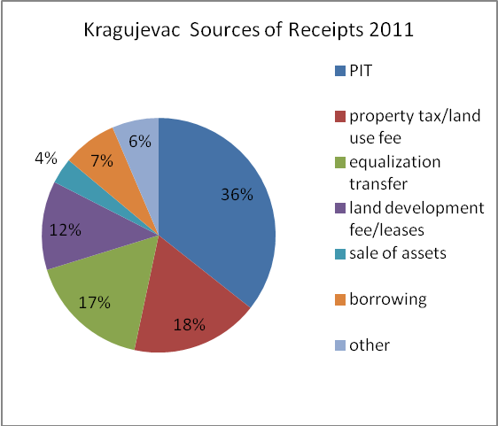
- Current revenues account for 93 percent of this. The remainder is derived from borrowing and the sale of assets. As in Belgrade, the largest single source of municipal revenue is the municipal share of the centrally-administered personal income tax. In 2011, PIT revenues accounted for 36 percent of total receipts. The results for 2011 reflect the partial impact of the decentralization amendment, which increased Kragujevac’ share of the PIT from 40 percent to 80 percent. The full impact of the increase will be observed in 2012. The city’s 2012 budget foresees an increase in PIT revenues of 75 percent over actual collections in 2011.

- The second largest source is the property tax and the related fee for use of urban land, which together accounted for just under 18 percent of current revenues in 2011. Revenue from leases of municipal property and the land development fee accounted for 12 percent. In 2011, Kragujevac also received non-categorical transfers from the central government of about RSD 830 million. Under the decentralization amendment, Kragujevac’ revenues from this source would drop. The 2012 budget foresees a drop of more than 50 percent (to RSD 383 million) but compensates with ‘capital transfers from other levels of government’ (budget classification 733240). Overall, the budgeted increase in PIT revenues is three times the budgeted losses from the reduction in equalization transfers. Kragujevac was a modest borrower in 2011. Proceeds from borrowing increased the total resource envelope by about eight percent.

Expenditures

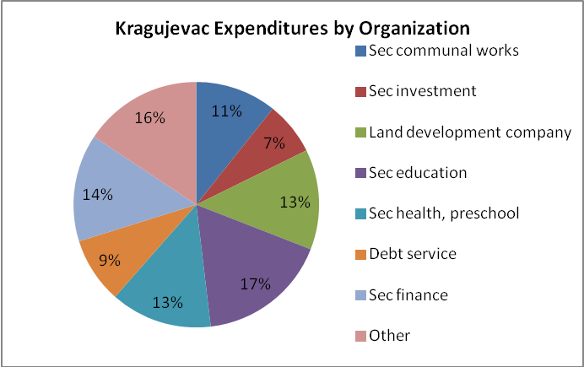
- In functional and organizational terms, Kragujevac, like Belgrade, devotes the largest share of its budget to infrastructure. Responsibility for infrastructure is divided among several departments and subordinate municipal enterprises. The largest single spender is the Department of Investment and Development. The 2011 budget execution report provides little detail on the sectoral allocation of Department’s expenditures. According to the 2012 budget, the largest single item of expenditure is the construction of a sports complex. Subordinate to the Department of Investment and Development is the Company for the Construction of Kragujevac, the city’s land development agency. In 2011, the company accounted for 13 percent of total municipal expenditures. The Company operates on a different business model than its counterpart in Belgrade. As noted earlier, the Belgrade agency generates revenues by charging a land development fee. While the Kragujevac company also does so (See Table B1) it recovers most of its costs by developing city owned land and then leasing it to private investors. (Leases are auctioned.) Its operations are therefore confined to land owned by the city. According to the Company, the supply of city-owned undeveloped construction land is running out. Most of the ruined industrial sites in the urban area are owned by the State. But the city has the option of expanding the officially-defined urban zone onto surrounding agricultural land—much of which is state-owned.
Table B1 Kragujevac Land Development Fee
(1 point = 1 Euro)
zone | Primary fee per 200 m^{2*} | Secondary fee per m²
 |  | Family housing per m2 | Multi-family housing | Business space | Add’l utility equipment
Extra zone | 10 | 27 | 40 | 60 | 50
Zone 1 | 10 | 16 | 30 | 50 | 30
2 | 10 | 14 | 27 | 40 | 30
3 | 10 | 13 | 24 | 35 | 30
4 | 6 | 4 | 10 | 10 | 5
5 | 6 | 0 | 8 | 4 | 0

- Also subordinate to the Department of Investment and Development is the city housing construction company, which is responsible for the construction of both market-rate and social housing. The company recently completed a major urban redevelopment and resettlement project. This involved the demolition of a barracks-style workers housing project, built in the 1920s, near the center of the city. Residents of the project were relocated, free of charge, into new apartment buildings constructed by the company. The former site was then sold to a private investor, who built market rate apartments and a shopping center. The company also manages the city housing fund, which provides zero-interest loans for energy efficiency improvements and repairs to the exteriors, roofs, and elevators of multi-family housing and on-lends funds from the central government housing agency to private home purchasers.

- The second large spender in the infrastructure sector is the Secretariat of Communal Works. Under the Secretariat are various public enterprises responsible for water supply, solid waste management, street construction, and public transport. (The district heating company serving the city belongs to the central government.) The city’s budget execution report for 2011 provides little detail on the composition of the Secretariat’s expenditures. In the 2012 supplementary budget, a total of RSD 940 million is allocated to the secretariat, of which just over half is allocated to ‘road traffic’, and the remainder to ‘community development’ and ‘streets’. Kragujevac does not have a municipal public transit company, but has contracts with two private operators for public transport.

- Taken together, spending by the Department for Investment and Development, its subordinate land development company, and Department of Communal Works accounted for 31 percent of total expenditures in 2011. Much of the remainder was spent in the social sectors. Spending by the Department of Health, Social Policy, Social Care, and Children consumed 13 percent of the 2011 budget. Details of the sectoral composition of the department’s expenditures are not shown in the 2011 budget execution report. According to the 2012 supplementary budget, roughly one-third of the department’s budget is allocated to preschools, with the remainder to various forms of social assistance. The secretariat of education, which maintains and operates school buildings for grades K-11, accounted for 17 percent of the city’s expenditures.

Nis

- Nis was once a major industrial city, with 70,000 manufacturing workers. Most its industrial enterprises have now collapsed and the city government is still in the process of finding new employers to replace them. The municipality has a population of 260, 237 of whom 187,544 reside in the officially designated urban area. Nis, like Belgrade, has its own city municipalities.

- Receipts in 2011 totaled RSD 6.99 billion, roughly €268 per capita. Current revenues account for 80 percent of this. As in Belgrade and Kragujevac, the largest single source of municipal revenue is the municipal share of the centrally-administered personal income tax. In 2011, PIT revenues accounted for 40 percent of total receipts. The results for 2011 reflect the partial impact of the decentralization amendment. As elsewhere, the full impact of the increase will be observed in 2012. The second largest source is the property tax and the related fee for use of urban land, which together accounted for just 14 percent of total receipts in 2011. Revenue from leases of municipal property and the land development fee accounted for 12 percent. Revenues from central government transfers contributed an equal proportion. (See Chart C1.)

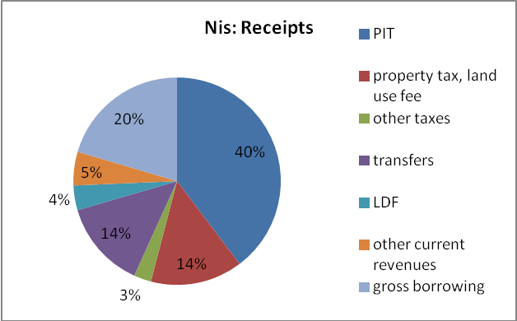
- In 2011, Nis borrowed on an even larger scale (proportionately) than Belgrade. Gross proceeds from borrowing constituted 20 percent of total receipts. According to the local authorities, this was a continuation of a massive investment program begun a year earlier. In 2010 city borrowed €6 million for street rehabilitation and €2.3 million for the construction of sports complex. Borrowing proceeds in 2011 were used to finance the construction of a sports complex. In 2012, the city intended to borrow another €2 million to complete the complex. The city now intends to invest in a wastewater treatment plant at a cost ranging from €70 million to €-230 million.
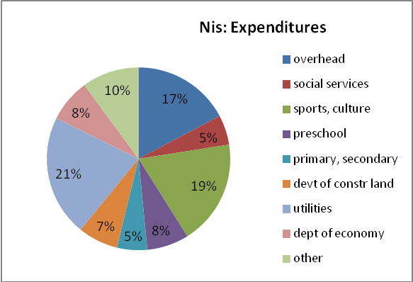
- In functional and organizational terms, Nis has a somewhat more diverse and opaque allocation of expenditures. As shown in Chart C2, 17 percent of 2011 expenditures were allocated to overhead, which largely consists of (1) salaries of employees paid from the budget; (2) debt service, and (3) transfers to the subordinate municipalities that (as in Belgrade) fall under the Nis administration. Another 19 percent is spent on sports and culture. (This may be an anomaly, reflecting debt-financed spending on the sports complex.) Twenty-one percent is spent on utilities, which largely consists of recurrent payments (contractual services) to the street cleaning company and park maintenance company and direct expenditures on ‘utility maintenance’, a term which is presumed to mean the maintenance/rehabilitation of water company and other utility assets. Very little of this (3.3 percent of total expenditures) is spent on public transport subsidies and even less (two percent of total expenditures) is spent on road maintenance. Seven percent is spent on the development of construction land. Eight percent spent on preschools. Only five percent is spent on primary and secondary schools.

Subotica

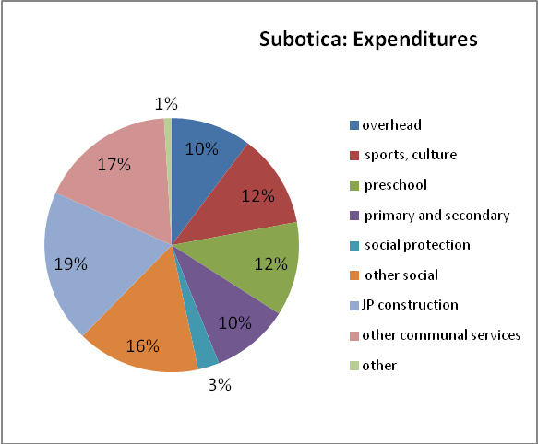
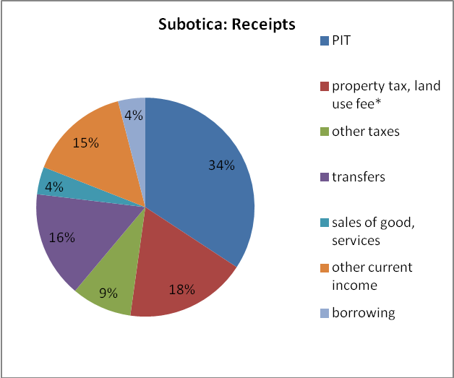
- Subotica is an up and coming town near the Hungarian border. The municipality has a population of 141,554 of whom 105,681 reside in the officially designated urban area. Receipts in 2011 totaled RSD 4.321 billion, roughly €305 per capita. Current revenues account for 87 percent of this. As in the other case study municipalities, the largest single source of municipal revenue is the municipal share of the centrally-administered personal income tax. In 2011, PIT revenues accounted for 31 percent of total receipts. The second largest source is the property tax and the related fee for use of urban land, which together accounted for 16 percent of total receipts in 2011. Revenues from central government transfers contributed a slightly smaller proportion (14 percent). In 2011, Subotica borrowed on a relative small scale. Gross proceeds from borrowing constituted four percent of total receipts. But the city is planning a major investment in wastewater collection: €11 million for construction of two collectors and two trunk lines, part of which will be financed from the NIP, the EBRD and the Balkan investment fund. (See Chart D1).

- In functional and organizational terms, Subotica’s expenditures are dominated by the social sectors. As shown in Chart D2, ten percent of 2011 expenditures were allocated to overhead (my term) which here defined as salaries of employees paid from the budget and debt service. Another 12 percent is spent on sports and culture. Twelve percent is spent on preschool and ten percent on the operating and maintaining primary and secondary schools. Other social spending, including social protection and pre-natal care and other health services accounted for another 19 percent. Payments to the city’s construction companies consumed 19 percent of the budget. Other spending on communal services consumed most of the remaining seventeen percent.
Annex 2 Acronyms Used in District Heating Charts

BEO | Beograd
BOR | Bor
CAC | Cacak
JAG | Jagodina
KRU | Krucevac
LES | Leskovac
NPZ | Novi Pazar
NSAD | Novi Sad
PAN | Pancevo
RUM | Ruma
SBA | Sbac
SUB | Subotica
UZI | Uzice
VAL | Valjevo

This figure excludes expenditures of the province of Voivodina as well the expenditures of municipal enterprises (water, sewer, district heating, public transit) that are financed from own-source revenues such as tariffs. It does, however, include subsidies from municipal budgets to their respective enterprises.
The term ‘block transfers’, in this report, refers to recurrent, unearmarked transfers to local governments.
2 Under the Serbian Constitution, Serbia consists of a central territory governed directly by the central government and two provinces. One, the province of Kosovo and Metohija, unilaterally declared independence in 2008 although this is not recognized by the Serbian authorities. The other, Vojvodina, performs some of the functions that are performed by the central government in the central territory. The province is largely financed from central government transfers. Most of its expenditures consist of transfers to municipalities within its jurisdiction. Due to its unique but limited role, it is not a subject of this study.
Two cities—Belgrade and Nis—are also divided into so-called ‘city municipalities’. Belgrade has 17 of them; Nis, five. In effect, they function as satellites of the municipal governments of Belgrade and Nis, respectively.
The ten smaller municipalities are: Aleksinac, Batocina, Backi Petrovac, Cacak, Kanjiza, Kraljevo, Krusevac, Subotica, Ub and Vrsac. The smaller jurisdictions represent a range of municipalities of different sizes and locations within the country. As municipalities lacking detailed expenditure data were excluded from consideration, the list is illustrative but not statistically representative.
The city’s revised budget for 2012 shows slightly more detail. Of the RSD 879 million allocated to the Department of Health, Social Policy, Social Care, and Children, roughly one third-is allocated to preschool education and the remainder to social assistance.
As noted earlier, the number was increased to 21 in 2007. The Government continued to calculate the transfer on the basis of the four original cities in through 2012. For 2013, it is not yet clear whether the calculation will be based on the four cities or on a larger number. The amended law refers only to ‘cities’ (gradava).
The law also specified that any local government whose shared revenues (per capita) exceeded 150 percent of the national average was to have 40 percent of the excess deducted and added to the pool of funds to be distributed to the remaining jurisdictions.
Fifty percent of the funds are allocated to municipalities in the lowest development category; 30 percent to those in the second lowest, and ten percent, each, to municipalities in the remaining two groups. The law defines how the funds are to be distributed among municipalities within each group.
This represents a substantial reduction in the rates for physical taxpayers, compared to the rates imposed at the reform of 2009. At that time, the rate on property (both land and buildings) was 0.4 percent of the first RSD 6 million of value; 0.8 percent the value (if any) between RSD 6 million- 15 million; 1.5 percent on the value between 15 million and 30 million and three percent on any value over 30 million.
In principle, land that has been converted to private ownership (see sections below) should no longer be subject to the fee. Anecdotal evidence (from Olivera) suggests that it continue to be, nevertheless.
Revenues from land development fees are volatile; sensitive to volume of construction activity. Nis reports that it now (2012) issues only seven or eight construction permits a month. During the boom (2008) they were issuing one hundred times as many.
In Belgrade, developers who provide onsite infrastructure at their own expense are permitted to deduct up to 40 percent of the fee. Developers are also permitted to pay the fee in installments over three to four years. Those who pay the entire sum up front are entitled to a 50 percent discount.
Changes to the laws will also set a three-year deadline for completing legalization. and will stipulate that “silence of the administration” for more than 90 days will be considered an approval of a legalization request, provided that there are no legal disputes over the property in question. Property under dispute will be subject to court proceedings and will have to be re-registered.
According to the Belgrade water company, some developers have already installed water lines at their own expense—some 500 km worth—but not to water company standards. The company also notes that development continues to occur far from existing trunk lines, despite the efforts of the city’s planning secretariat to encourage more compact urban expansion. More informal processes are said to operate on the urban fringe, where land is zoned for agriculture. In those areas, the occupant (or owner, in the case of parcels of less than 10 hectares) has the right to use the land for agricultural purposes. An individual who wishes to build a house on the property will typically make a private agreement with occupant of the land and proceed to build without official permission. The municipal land development agency cannot legally extend roads, water, sewer, to the house since the land is not zoned for urban development. The land development agency may nevertheless extend the infrastructure informally. While the homebuilder cannot be charged the land development fee, informal payments are said to occur.
World Bank. 2012. Republic of Serbia: The Road To Prosperity: Productivity and Exports
The conversion fee applies only to undeveloped land and land that was acquired by legal persons (companies) as a result of privatization or bankruptcy. According to Article 101 of the 2009 Law on Planning and Construction (law 72/2009) conversion is automatic and without charge for a physical person who is the owner of a building and has registered occupancy rights to the land beneath it. (This provision went into effect on the day Law 72 was enacted.) A legal person who has acquired land occupancy rights through the purchase of a privatized state or social enterprise may convert that occupancy right into an ownership right, but only by paying a conversion charge equal to the market value of the property at the time of conversion, less the expenses of gaining the right to the use of that land. (Article 103). In the case of occupancy rights to land which has not yet been developed (in the case of both physical and legal persons) occupancy rights may be converted into ownership rights through the payment of a conversion charge equal to the market value of the property at the time of conversion, less the expenses of gaining the right to the use of that land, 'with reassessment calculated up until the moment of payment made on this basis' (article 104). ‘Expenses of gaining the right to the use of land' are based on the book value of those rights at the time the current owner first acquired them. This value is calculated by the privatization agency at the time the company is offered for sale. It is not yet clear how are the ‘current market value’ is determined. According to Article 107, 50 percent of the revenue generated through conversion payments is transferred to the municipality, with the remainder going to a conversion fund. As of the time the 2012 CEM was written, the Government had failed to issue the necessary regulations and had been slow in processing applications for conversion.
According to the law, ‘the subject of restitution shall be construction land in the public ownership of the Republic of Serbia, Autonomous Province or local self-government unit, as well as construction land in state, social and/or cooperative ownership. Construction land with structures shall not be returned, unless otherwise determined by the Law in individual cases.
According to the law, ‘the party obliged to make restitution of nationalized property in its natural form (i.e., by returning the property itself) shall be the Republic of Serbia, Autonomous Province, a local self-government unit, a public enterprise, a company, or other legal entity founded by the Republic of Serbia, Autonomous Province or a local self-government unit, a company with majority socially-owned capital and a cooperative, also including companies and cooperatives in the insolvency and liquidation proceedings which were on the date of entry into force of the Law, the owner, possessor or holder of the right of use and/or disposal with nationalized property – in terms of the right that belongs to them.’ But if the property cannot be returned to the claimant, compensation is paid, in the form of government bonds or cash, by the Republic of Serbia.
Revenues are defined as total receipts, less proceeds from borrowing. Expenditures are defined as total expenditures less principal repayments.
The Serbian Ministry of Finance uses the IMF’s GFS classification system, which distinguishes between subsidies, which it defines as ‘current unrequited payments that government units make to enterprises on the basis of the levels of their production activities or the quantities or values of the goods or services they produce’, and transfers, which are ‘noncompulsory current or capital transfers from one government unit to another government unit.’ If municipalities faithfully follow this classification system in their financial reporting, it would suggest that price subsidies—such as discounted fares for public transport or water subsidies—fell during this period, while transfers to municipal enterprises and other non-budget entities based other criteria increased. In practice, this distinction is probably not meaningful. Belgrade, for example, may have transferred funds to its transport company in the form of block grant, even though it ultimately permitted the transport company to subsidize ticket sales.
Much of this, in turn, represents loans from EBRD and EIB to finance Belgrade’s share of the cost of constructing the new Ada Bridge over the Sava River. If Belgrade can be restrained from such operations in the future, its deficit could disappear on its own.
Local governments have also been granted the right to collect 100 percent of the revenues from the lease of state owned agriculture land. This will increase local revenues by another RSD 2.9 billion. These estimates are from the Fiscal Council, Republic of Serbia, 2011.
See for example “Spotlight on 1. An Analysis of the Proposal to Increase the Local Governments’ Share in the Wage Tax” by Milojko Arsić and reports by the Fiscal Council.
Data is from Public Finance Bulletin of March 2012 and Belgrade budget execution report for 2010.
According to the government’s September 2012 supplementary budget, transfer to cities and municipalities in 2012 will total RSD 33.2 billion, which is indeed one percent of GDP.
This conclusion is based on the following calculation: In 2010, the average per capita PIT revenues of all municipalities (except the four cities that are statutorily excluded from the calculation) was RSD 5820. Assuming that the per capita revenues of poorer jurisdictions are exactly 25 percent below the average, the cost of bringing all jurisdictions up to 100 percent of the national average would be RSD 1454 per capita. Assuming half Serbia’s population (excluding the four cities) live in this group of municipalities, the total cost of bringing all jurisdictions up to 100 percent of the national average would be RSD 3.5 billion. The total amount of non-categorical transfers in 2010 would have been RSD 50.8 billion, if the transfers had been fully funded. As the estimated cost of the equalization component (RSD 3.5 billion) is equal to only seven percent of that amount, it is assumed that the general fund component dominates.
Current estimate, according to MOF Fiscal Strategy, October 2012.
Data for NMS countries is from 2007 or 2008, depending on availability.
Based on the comparison of the October-August wage bill in 2011 and 2012.
This problem is addressed, to an extent, by the formula for allocating central government financial support in 2013. The RSD 4 billion will be allocated according to the length of roads transferred to each jurisdiction, at the rate of €5000 per kilometer. Municipalities argue that this falls far short of the amount needed to adequately maintain the roads. As a result, they will have to pay part of the additional costs from their own budgets.
The absence of accurate data on ownership should not be a major constraint on administering the property tax. According to the current Serbian property tax law, liability extends to any form of ownership or usufruct rights. When the holder of the right to the property is unknown or not designated, the user is liable for the tax. As a result of this broad definition, the ongoing process of title conversion (from occupancy to ownership) will not affect the base of the property tax.
Much of the recurrent property tax in the UK is derived from industrial and commercial properties, which are taxed by the central government. The revenues are transferred to municipalities, but not on the basis of origin.
Radulovic, Branko, January 2012. Serbia Local Public Utilities: An Overview
These figures may slightly overstate the dominance of the four sectors. Financial data is available for all district heating companies and about 95 percent of companies in the other three sectors, but is less complete for other types of municipal enterprises.
Data is from PUC mini-data base.
Data is from BOOST.
World Bank. April 2012. Program Document for a Proposed (DPL) to the Republic of Serbia for a First Programmatic Public Enterprise Restructuring Development Policy Loan (Concept Version)
The company’s financial statements do not show the amount of subsidies from the municipal budget. According to the city’s own budget execution report (2011) expenditures on water supply totaled RSD 1,309 million, of which RSD 787 million was classified as ‘subsidies to non-financial public enterprises and organizations’. This figure is roughly consistent with the figure the company reports for ‘operating revenues from sources other than sales’ (RSD 828 million. This assumes that all subsidies from the budget were for operating costs--a not unreasonable assumption, as the municipality itself pays for most capital investment in the water sector, rather than transferring the funds to the water company. The Belgrade water company does undertake some capital investments of its own, however. According to the company’s cash flow statement Belgrade water company spent RSD 2,899.3 million on investments in 2011, plus another RSD 221 million on ‘related’ investment expenses. This was financed from the net cash flow from operations (RSD 766.9 million) plus cash inflow from investments borrowing and other long and short term liabilities. A small part was also financed by drawing down cash.
International Benchmarking Network for Water and Sanitation, 2012, Collection and Analysis of Utility Performance Benchmarks for Serbia for 2007-2011.
According to Belgrade water company’s financial statement, the company reduced its staffing levels from 2975 in 2008 to 2467 in 2011. Spending on wages, however, did not decline.
Substantial tariff increases are expected in other sectors as well. According to Serbia news of September 25, the price of district heating in Belgrade will go up 18.5% on October 1, 2012. (The level was last fixed November 1, 2011. Inflation in the last two quarters of 2011 and the first two quarters of 2012 totaled only about five percent. Public transportation fares will rise 20% (over the level last fixed on January 1, 2011). District heating bills in most other cities across Serbia are expected go up by between 10% and 20% in October.
Ministry of Regional Development and Local Self Government, September 2012, Economic Analysis of Local Public Utility Companies’ Performance. The report deliberately excludes the two largest district heating companies: Belgrade and Novi Sad. Two other companies did not report financial results.
The PUC data base is a compilation of basic financial statistics for public utility enterprises, based on the financial reports each enterprise is required to file with the Government.
This may understate the extent to which tariffs fail to cover operating costs, however. The company reportedly has a substantial backlog of arrears to Serbia Gas
It is not yet clear whether these arrears distort the profit and loss reports of individual companies or the figures on municipal subsidies. If the companies report expenditures on an accrual, rather than cash basis, the profit and loss statements would reflect expenditures accrued but not paid. But they would tend to understate the extent to which the companies are being subsidized. As long as the arrears go unpaid, the companies are being subsidized by their creditors, rather than by their municipal owners.
These figures should be used with caution. On one hand, they exclude arrears owed by the Belgrade and Novi Sad companies and therefore may understate the size of the stock. On the other hand, they include arrears owed by industrial concerns that have now been assumed by the district heating companies. According to a separate study of municipal arrears by the Standing Conference of Town and Municpalities, the stock of arrears owed to Serbjagas by all municipal utility companies (excluding Belgrade) totaled only RSD 2.5 billion as of April 2010.
This low figures for Bor and Krusevac are explained, to some extent, the fact that that both companies rely on coal-fired boilers, which are more labor intensive than other boilers using other fuels. This does not explain the low figures of the companies that rely, like Novi Sad, on natural gas.
According to the PUC data base, there are only 5,241 employees in the 40 companies covered by the data base and 43 percent of them work in Belgrade.
Veolia LUV, Tamnava, Ćurdić, Lui travel, Autokodeks and Presto
However, nine electric trains (7 in operation, 2 in so-called “hot reserve”) were renovated by the City of Belgrade for the new BG:Voz rail commuter service, which started operating in April 2011
An earlier study by the World Bank found that ticket revenue covered 34 percent of GSP Beograd’s total operating costs in 2002. Both the 2002 and 2011 numbers are based on flawed accounting systems, with low depreciation and questionable treatment of such transactions like one-time revenues, capitalized repairs, contributions to funds, etc. A new systemic law for accounting is in the parliamentary approval stage.
The loan covers half of the estimated cost of Euro 130 million for the purchase of 280 modern articulated diesel powered urban buses and 120 CNG powered buses. The open tender for the purchase of 180 modern articulated urban buses was completed on October 18, 2012. EBRD has tried to find other commercial banks to support the remaining half of this scheme—an additional Euro 65 million—but as it is something new and still uncertain, this has not yet taken place. The loan requires GSP Beograd to develop a Retrenchment Plan and the preparation of a Restructuring Plan, with a focus on the transformation to a holding structure by mode of transport, mode specific public service contract, staffing and operational efficiency improvements, and partnering with the private sector
The penalty is RSD 1500 (US$ 17.35) if paid within 15 days. Otherwise it is RSD 3000 (US$ 34.70).
Under a gross-cost contract, the transport authority pays the operator a specified sum, which is intended to cover the entire cost of operating a line. Operators turn over any tariff revenue to the transport authority. Under a net cost contract, the operator retains any tariff revenues. Subsidies from the transport authority, if any, are intended to cover only the expected difference between operating costs and tariff revenues
Though the Master plan mentions financial sustainability, its explicit financial content is limited to investment cost estimates. Operating costs and revenues, pricing and financing policies have not become valid subjects in this approach to strategic planning.
The maintenance fee accounted for 47 percent of budgeted revenues and the cleaning fee another 17 percent. Another ten percent was derived from rental income, seven percent from special contracts for major works (see text) and five percent from subsidies for low income households. There is no record of transfers to the company in the city’s 2011 budget execution report.
Strategy for Restructuring the Public Utility Companies in Serbia. June 24, 2011
In addition, Government of Province of Voivodina as a sub-national government has issued a bond in June 2012.
These local governments are: Arandjelovac, Belgrade, Kikinda, Pirot, Pozarevac, Ruma, and Valjevo.
According to Nikolic (2012) Belgrade borrowed EUR 289.6 million for this project alone. Creditors are EBRD and EIB. These loans have a sovereign guarantee.
This calculation assumes that the stock of debt is financed at six percent interest and ten years to maturity.
At six percent interest and ten years to maturity, loans totaling 50 percent of current revenues would require debt service equal to 13.6 percent of current revenues.
If local government has some self-liquidating debt—where investment generates revenue to liquidate the debt—then that might be a different story. You could make an exception. In fact, this is what the EBRD is trying to do with Belgrade transit: make the transit company the borrower, and repay from tariff revenues. But this is not such a good idea in practice. If Belgrade transit can’t service the debt, what happens? Even EBRD is covering this contingency: requires Belgrade to raise tariffs enough to service the debt or (check this) repay the debt itself.
This tax is levied on gross wages at the rate of 12 percent, after deduction of the non-taxable base of RSD 5,560.
All public sector employees (including members of the military, health workers etc,) as well as the poor are eligible The city’s current housing program sells housing units to government employees at cost, with 20 percent down, 20 years to pay, and 0.5 percent interest. The Agency is now completing the construction of 2000 such units. (The project is 90 percent complete.) Income from the program is shown in the budget execution reports and mostly consists of down payments. The Agency also operates a smaller program of social housing, mostly financed from donations.
One of the agency’s largest current programs is the reconstruction of Vojvode Stepe Street, where existing tramlines will be located from the edges to the center of the street. The project is estimated to cost €20 million and will be financed by EBRD.
Daily, the GSP transports about million passengers on approximately 138 lines, using about 1000 vehicles at the daily peak. The Enterprise employs around 7,000 employees.
According to the city website, the company maintains approximately 4000 city streets, 550 km of local and 630 km regional roads in the territory of the City of Belgrade, as well as 485 light-controlled intersections and 120,000 traffic signs, and it is responsible for the maintenance of 400 bridges. The Company employs around 1500 employees. The construction operations department takes care of repairs and improvements to the carriageways and pavements in the City area and maintains regional and local road structures (such as bridges, abutment and retaining walls, etc.). The traffic operations department maintains traffic equipment, markings, traffic signs, etc. The Company produces asphalt, concrete, and road equipment.
Including borrowing but excluding tariff revenue retained by municipal enterprises,
The 2011 final accounts do not provide a breakdown of revenues from these two sources. Both are combined under the category ‘total revenues from the sale of goods and services’ (code 742000) . The budget for 2012 provides greater detail. Revenues from ‘the sale of goods and services by market organizations for the benefit of the city’ (code 742140) are budgeted at RSD 3.075 billion. According to the city’s finance department, this represents income from 99-year leases of construction land. Revenues from the land development fee (code 742250) are budget at only RSD 350 million.
Despite its title, the agency is a direct budget user. Its revenues and expenditures are reported in the budget.
In 2011, out of total spending of RSD 518 million, RSD 251 million was spent on ‘specialized services’ and RSD 194 million on ‘subventions to public non-financial companies and organizations’.
Including borrowing but excluding tariff revenue retained by municipal enterprises,
The 2011 final accounts do not provide a breakdown of revenues from these two sources. Both are combined under the category ‘total revenues from the sale of goods and services’ (code 742000) . The budget for 2012 provides greater detail. Revenues from ‘the sale of goods and services by market organizations for the benefit of the city’ (code 742140) are budgeted at RSD 3.075 billion. According to the city’s finance department, this represents income from 99-year leases of construction land. Revenues from the land development fee (code 742250) are budget at only RSD 350 million.
Including borrowing but excluding tariff revenue retained by municipal enterprises,

